Water Quality Assessment of the Kenai River Watershed from 2000 to 2025 [DRAFT]
Benjamin Meyer, Kenai Watershed Forum
2026-03-28
Table of contents
Preface 3
Acknowledgements 5
Abstract 6
Units 7
Acronyms 8
1. Introduction 9
2. Study Area 10
2.1 Description 10
2.2 Figures/maps 10
2.2.1 Online Map of Sample Sites 10
2.3 Sampling Site Descriptions 12
2.3.1 Kenai River Mainstem Sites 12
2.3.2 Tributary Sites 25
3. Methods 35
4. Data Sourcing 36
5. Data QA/QC 36
6. Interpreting Boxplots 37
6.1 Interpreting Box Plots 37
7. Regulatory Limits 38
7.1 Metals 38
7.1.1 Metals with Static Regulatory Threshold Values 38
7.1.2 Metals with Hardness-Dependent Regulatory Values 39
7.2 Hydrocarbons 40
7.2.1 Total BTEX 40
7.3 Nutrients (Nitrogen and Phosphorus) 41
7.4 Fecal Coliform Bacteria 41
7.5 Total Suspended Solids 42
7.6 Other Parameters 42
8. Arsenic 43
9. Cadmium 45
10. Chromium 47
11. Copper 50
12. Lead 52
13. Zinc 55
14. Calcium 58
15. Iron 60
16. Magnesium 62
17. Nitrate 64
18. Phosphorus 66
19. BTEX 68
20. Fecal Coliform Bacteria 71
21. pH 74
22. Specific Conductance 76
23. Total Suspended Solids 78
24. Turbidity 81
25. Temperature 83
26. Summary 86
References 86
Appendix A — Appendix: Data Review and Upload 88
A.1 Introduction 88
A.1.1 Year 2021 Water Quality Data 88
A.1.2 2021 Provisional Results, Prior to QA/QC Review 90
A.1.3 2021 Data QA/QC Evaluation 90
A.1.4 Uploading 2021 data to the EPA Water Quality Exchange (EPA WQX) 104
Appendix B — Appendix: Sample Event Timing 108
B.1 Introduction 108
B.1.1 Import data 109
B.2 Dates 109
B.3 Time of Day 112
Appendix C — Project Financial History 113
Appendix C — Summary 113
C.1 Inflation leads to declining project income 114
C.2 Income Detail 115
C.2.1 Notes on income history 115
Appendix C — Expenses 118
C.1 Expenses History 118
C.2 Projected 2025 Expenses 119
Appendix C — Recommendations 119
C.1 Source Data 120

Preface
Note: this online report is not optimized for use on mobile devices, and is best accessed on a desktop or laptop computer.
This document is a report on the project, “Water Quality Assessment of the Kenai River Watershed, 2000 - 2025.” It is an update to historical reports summarising available data to date (McCard 2007; Guerron Orejuela 2016).
This draft report is best accessed as an online interactive document at https://kenai-watershed-forum.github.io/kenai-river-wqx/, where it can also be downloaded as an Microsoft Word document.
All project files and source code are hosted in a public GitHub repository, also accessible at the above URL.
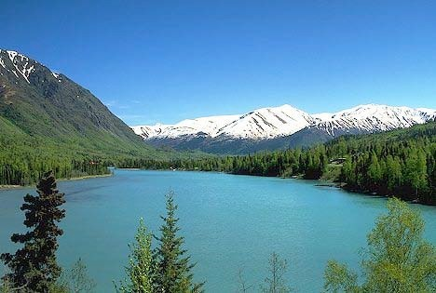
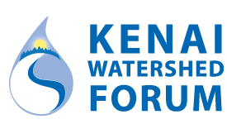

Acknowledgements
This study could not have been completed without the assistance and cooperation of many state agencies including the Alaska Department of Environmental Conservation (ADEC), the Alaska Department of Natural Resources, and the Alaska Department of Fish and Game. The Kenaitze Indian Tribe, Salamatof Tribe, Tyonek Tribal Conservation District, Cook Inlet Aquaculture Association, SGS Alaska Laboratories, Analytica Laboratories, Kenai Peninsula Trout Unlimited, Defenders of Wildlife, and Taurianen Engineering and Testing also supported this project. Additional cooperation transpired with the United States Forest Service, the United States Fish and Wildlife Service through the Kenai National Wildlife Refuge, the Kenai Peninsula Borough, the City of Soldotna, and the City of Kenai. Finally, many landowners graciously allowed access to the Kenai River and its tributaries from their property.
Thank you to all the staff at the Kenai Watershed Forum that made this project possible. Special thanks to …

Abstract
The Kenai Watershed Forum and governmental agencies formed a cooperative partnership to collect and analyze synoptic water samples from 13 locations along the Kenai River mainstem and from eight of its tributaries every spring and summer from 2000 to present day. Laboratory quantification was conducted on dissolved metals, total metals, nutrients, hydrocarbons, fecal coliform bacteria, and several other parameters. We also collected and assessed in-situ parameters such as pH, dissolved oxygen, water temperature, turbidity, and conductivity. These results are herein compared to Alaska and federal water quality standards for freshwater aquatic life.
[Summarize details of final results here when available].

Units
Conversions:
- 1 gram = 1000 micrograms
- °F = 9/5(°C) + 32
Unit Abbreviations:
- mg/L = milligrams per liter
- μg/L = micrograms per liter
- CFU/100m = coliform forming units per 100 milliliters
- μS/cm = microsiemens per centimeter
- NTU= nephelometric turbidity unit

Acronyms
- USEPA (United States Environmental Protection Agency)
- ADEC (Alaska Department of Environmental Conservation)
- DRO (Diesel Range Organics)
- GRO (Gasoline Range Organics)
- RRO (Residual Range Organics)
- BTEX (Benzene, Toluene, Ethylbenzene, and Xylenes)
- MDL (Method Reporting Limit)
- MDL (Method Detection Limit)

1. Introduction
This report summarizes water quality data collected between summer 2000 and summer 2021 from 22 sampling locations in the Kenai River mainstem and its tributaries. Local, state, federal, and tribal government entities, as well as several local non‐profits formed a cooperative partnership so that sampling teams from various agencies were able to collect water samples twice per year, once in the spring and once in the summer. This biannual effort continues beyond the publication of this report. The locations of the sampling sites are identified with maps, GPS coordinates, and photographs. Trends in the data are highlighted, and the results are compared to the Alaska and federal water quality standards for freshwater aquatic life.
The water quality data focuses on metals, nutrients, hydrocarbons, fecal coliform bacteria, and various field parameters. Dissolved metals in this analysis include arsenic, cadmium, chromium, copper, lead, and zinc. Calcium, iron, and magnesium were reported as total metals. Additionally, the report addresses the nutrients nitrate and phosphorus. Hydrocarbons parameters includes BTEX (benzene, toluene, ethylbenzene, m,p-xylene, and o-xylene). Fecal coliform bacteria, pH, specific conductance, total suspended solids, turbidity, and water temperature are the remaining parameters included in the analysis.
The results are displayed in graphs with associated written analyses and tables. The graphs display the median and variance for each parameter at a specific location, and these graphs are separated depending on whether the data was collected in the spring or in the summer. In some cases, parameters were present in levels that could not be detected by available laboratory analysis methods, and when this occurred with over 80% of the samples, scatter plots have been displayed omitting the unknown low levels.
Previous comprehensive reports for this project were published in 2007 and 2016 (McCard 2007; Guerron Orejuela 2016).
[Text from 2016 report: A trend analysis was conducted for the following parameters: Lead, Zinc and BTEX; based on the nature of the data, a polynomial line was used because it is the best way to capture and represent the fluctuations in the data.]
Complete data tables are available as downloadable spreadsheets for each parameter within its respective chapter.

2. Study Area

2.1 Description
Located in southcentral Alaska, the Kenai River is part of the Cook Inlet Basin and is linked to the surrounding communities through sport, commercial, personal use, and susbsistence fishing; as well as tourism, and recreation (Figure 2.1). At least twenty-seven fish species, including six species of anadromous Pacific salmonids flourish in the Kenai River watershed, with sockeye (red) and Chinook (king) salmon as the primary species of interest for harvest and sport fisheries (Schoen et al. 2017; Willette, Edmundson, and DeCino 2004). The Kenai River his historically produced 80% of the sockeye harvested in Cook Inlet (Dorava and Milner 2000).
Surface runoff, groundwater composition, natural minerals, aquatic plants and animals, and human activities can affect water quality in this area. Potential sources of pollution from humans include gasoline powered boat engines, agriculture, mining, street runoff, and perforated septic tanks (Glass, RL 1999; Reeves et al. 2018; EPA 2011).

2.2 Figures/maps

2.2.1 Online Map of Sample Sites
Access ArcGIS Online project map at https://arcg.is/0LXGSf
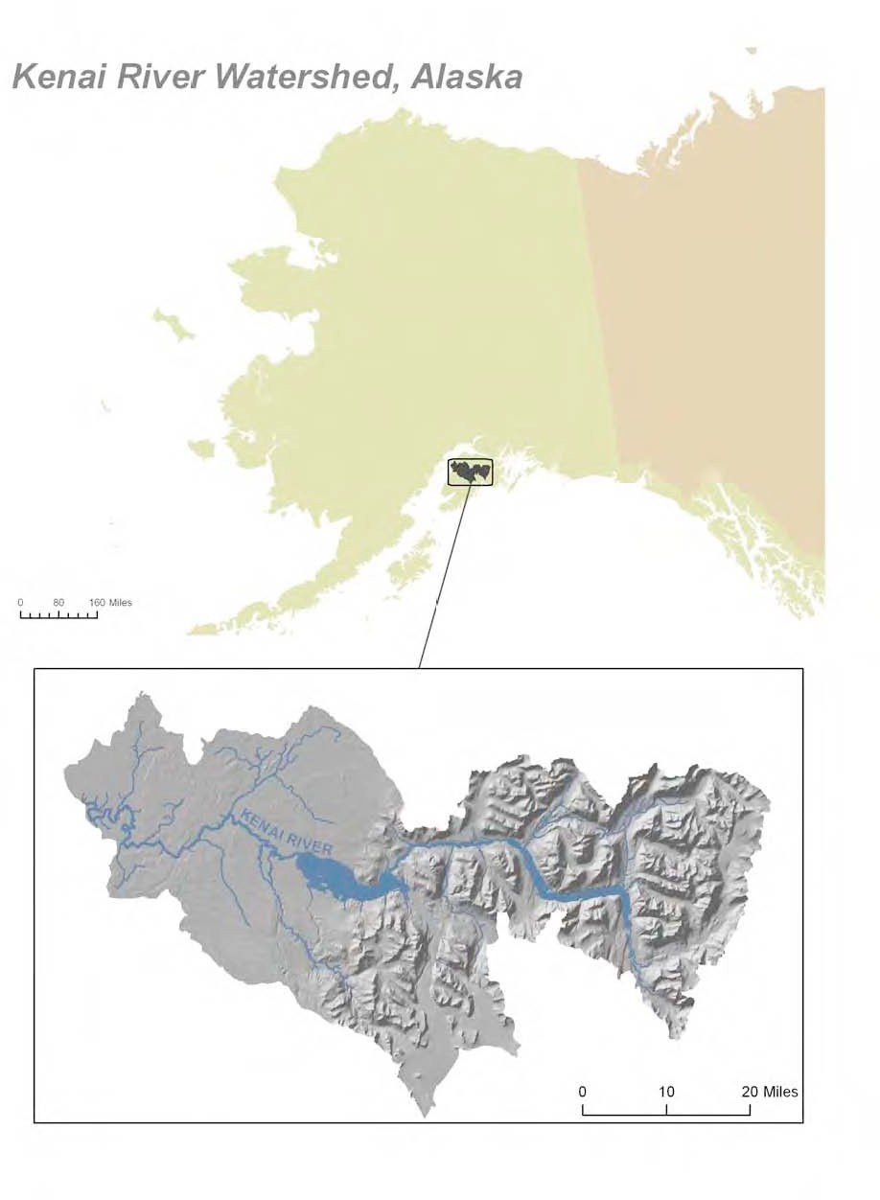
Figure 2.1: Location in Alaska of Kenai River Watershed

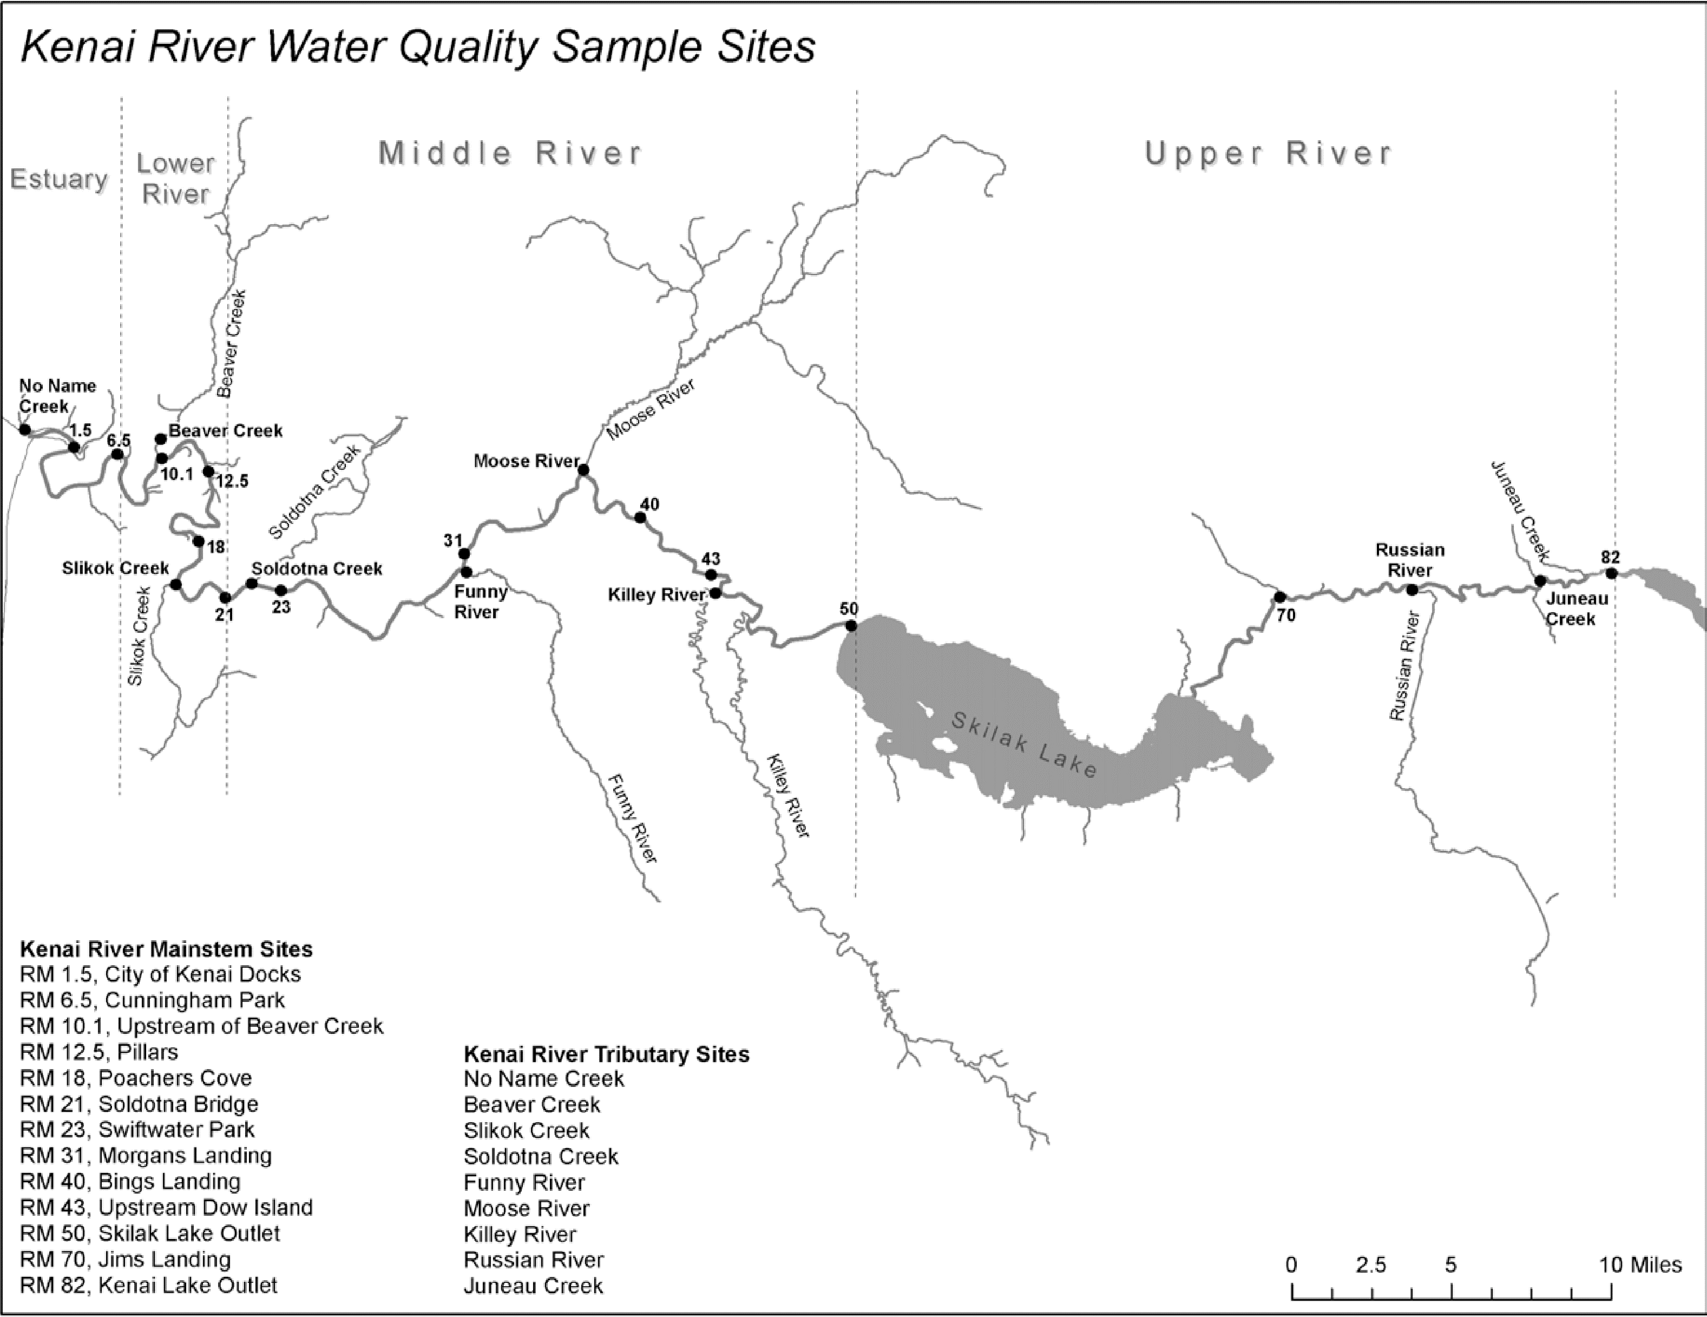
Figure 2.2: Location of water quality sampling sites

2.3 Sampling Site Descriptions
Field sampling sites shown in Figure 2.2 are described below with coordinates, collection notes, and a representative photo. Site descriptions and photos are reproduced from the 2016 Kenai Watershed Forum Baseline Water Quality Assessment report; photos may be updated in future revisions of this report.

2.3.1 Kenai River Mainstem Sites

2.3.1.1 Kenai River Mile 82
This site is near the Kenai Lake Outlet and Kenai Lake Bridge and is located at 60.492007 N and -149.810844 W. Samples are typically collected downstream of the boat launch.
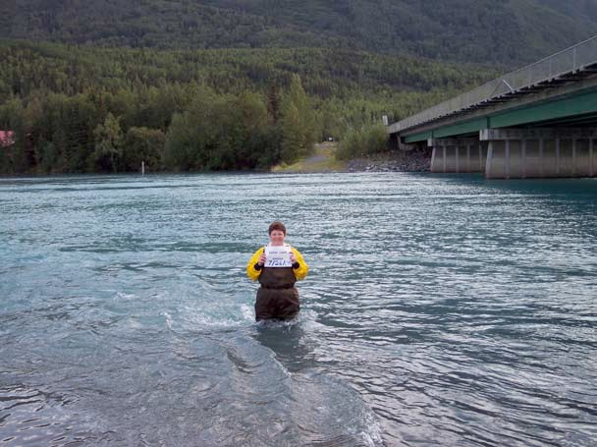
Figure 2.3: Kenai River Mile 82 (Kenai Lake Outlet), 07/26/05

2.3.1.2 Kenai River Mile 70
This site is near Jim’s Landing and is located at 60.481392 N and -150.115020 W. The sample is typically collected 40 feet downstream of the boat launch.
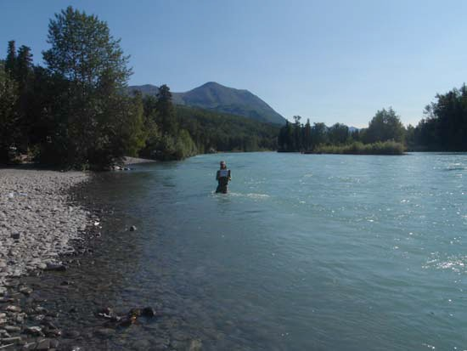
Figure 2.4: Kenai River Mile 70 (Jim’s Landing), 07/22/14

2.3.1.3 Kenai River Mile 50
This site is near the Skilak Lake Outflow and is located at 60.467517 N and -150.507789 W. Samples are typically collected between the swan signs off of the south bank.
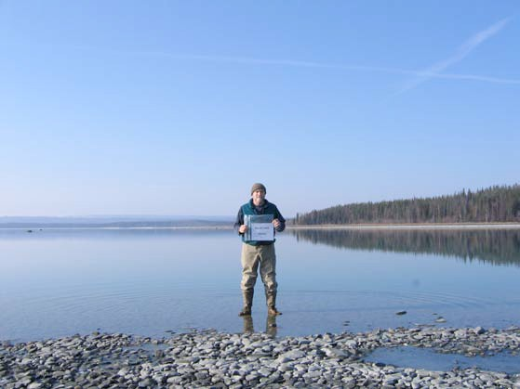
Figure 2.5: Kenai River Mile 50 (Skilak Lake Outflow), 04/22/08

2.3.1.4 Kenai River Mile 43
This site is upstream of Dow Island and is located at 60.489844 N and -150.636905 W. The samples are typically collected 100 feet upstream of the point of Dow Island.
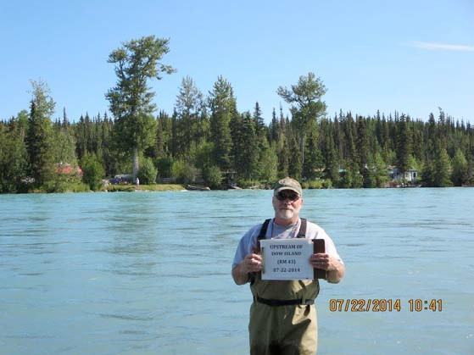
Figure 2.6: Kenai River Mile 43 (upstream of Dow Island), 07/22/14

2.3.1.5 Kenai River Mile 40
This site is near Bings Landing and is located at 60.515441 N and -150.702069 W. Samples are typically collected in front of the boat launch near the center of the river.
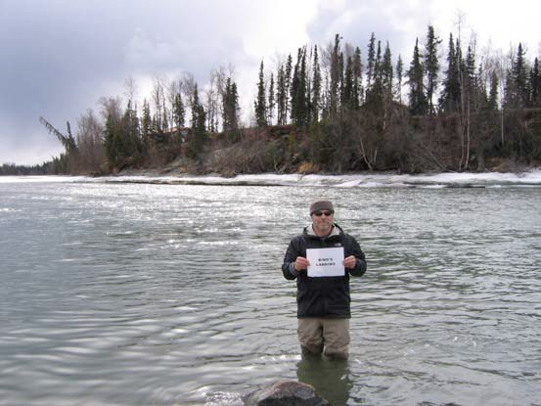
Figure 2.7: Kenai River Mile 40 (Bings Landing), 04/26/11

2.3.1.6 Kenai River Mile 31
This site is near Morgan’s Landing and is located at 60.498284 N and -150.863121 W. Sampling typically occurs down the abandoned steep road behind the headquarters building.
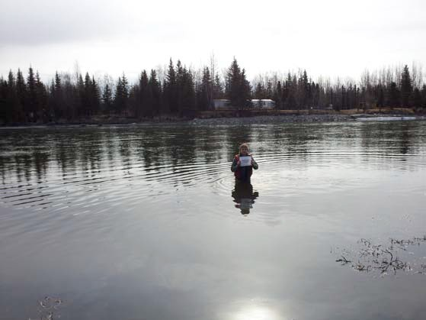
Figure 2.8: Kenai River Mile 31 (Morgan’s Landing), 05/01/12

2.3.1.7 Kenai River Mile 23
This site is near Swiftwater Park and is located at 60.480338 N and -151.030847 W. Samples are typically collected mid-channel in front of the ramp.
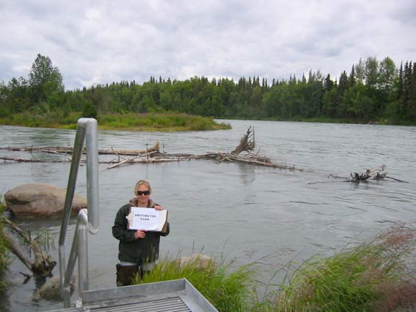
Figure 2.9: Kenai River Mile 23 (Swiftwater Park)

2.3.1.8 Kenai River Mile 21
This site is near the Soldotna Bridge and is located at 60.476634 N and -151.082099 W. Samples are typically collected 20 feet downstream of the bridge on the south bank.
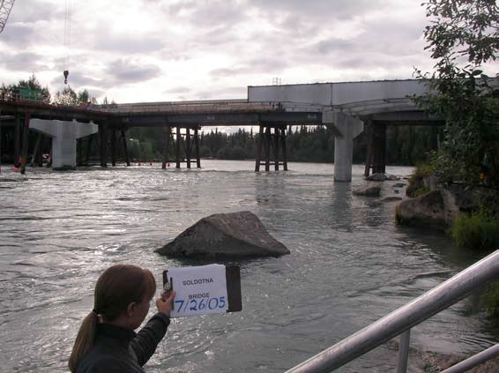
Figure 2.10: Kenai River Mile 21 (Soldotna Bridge), 07/26/05

2.3.1.9 Kenai River Mile 18
This site is near Poacher’s Cove and is located at 60.502005 N and -151.106973 W. Samples are typically collected mid-channel just downstream of an island.
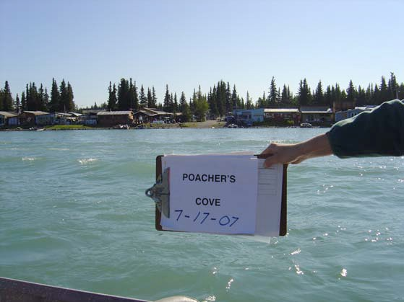
Figure 2.11: Kenai River Mile 18 (Poacher’s Cove), 07/17/07

2.3.1.10 Kenai River Mile 12.5
This site is near the Pillars Boat Launch and is located at 60.533743 N and -151.099258 W. Samples are typically collected toward the center of the river across from the dock.
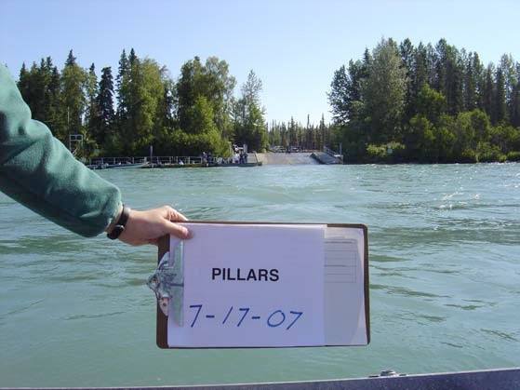
Figure 2.12: Kenai River Mile 12.5 (Pillars Boat Launch), 07/17/07

2.3.1.11 Kenai River Mile 10.1
This site is upstream of Beaver Creek and is located at 60.539279 N and -151.142263 W. Samples are typically collected 200 yards upstream of the Beaver Creek and Kenai River confluence. During July 2000, April 2001, and July 2001, samples were collected downstream of the Kenai River and Beaver Creek confluence. No samples were collected from this site from several spring sampling events due to challenging access terrain.
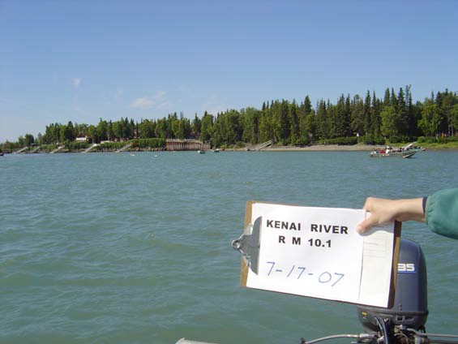
Figure 2.13: Kenai River Mile 10.1 (upstream of Beaver Creek), 07/17/07

2.3.1.12 Kenai River Mile 6.5
This site is near Cunningham Park and is located at 60.540810 N and -151.182780 W. Sampling typically occurs straight out from the public-use boardwalk and can vary due to tidal stage.
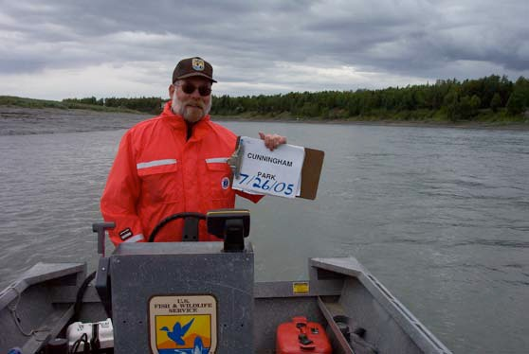
Figure 2.14: Kenai River Mile 6.5 (Cunningham Park), 07/26/05

2.3.1.13 Kenai River Mile 1.5
This site is near the City of Kenai Dock and is located at 60.543680 N and -151.222940 W. Samples are typically collected at the north end of the public fueling dock.
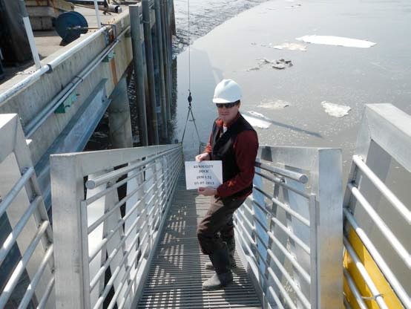
Figure 2.15: Kenai River Mile 1.5 (Kenai City Dock), 05/02/13

2.3.2 Tributary Sites

2.3.2.1 Juneau Creek
This site is located at 60.481392 N and -150.115020 W. The sample is typically collected 40 feet downstream of the boat launch at Alaska Wildlands.
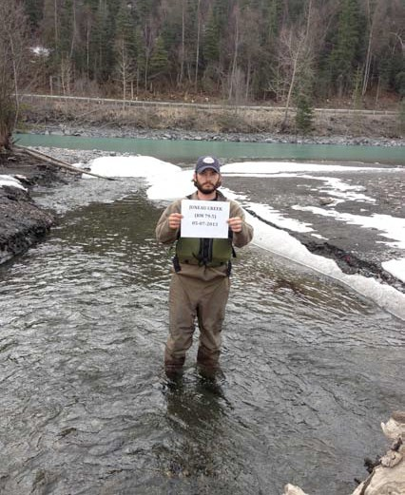
Figure 2.16: Juneau Creek looking downstream, 05/07/13

2.3.2.2 Russian River
This site is a Kenai River tributary and is located at 60.484622 N and -149.993955 W. Samples are typically collected 90 feet upstream of the sanctuary sign.
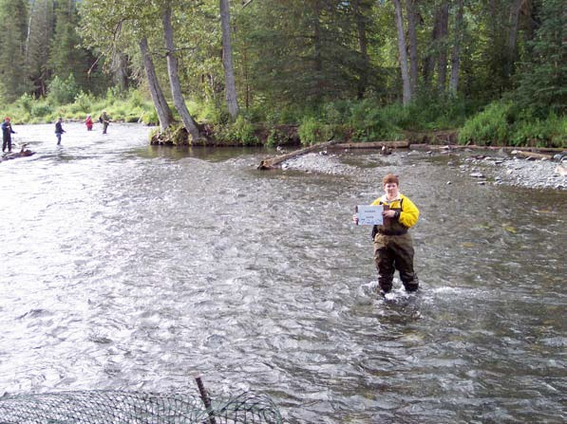
Figure 2.17: Russian River looking upstream, 07/26/05

2.3.2.3 Killey River
This site is a Kenai River tributary and is located at 60.481518 N and -150.632498 W. Sampling typically occurs 100 yards upstream from the Kenai River confluence across from the fish table.
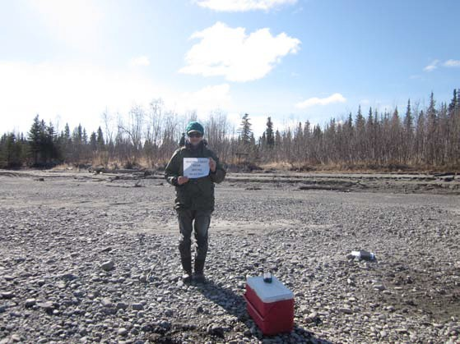
Figure 2.18: Killey River, 04/29/14

2.3.2.4 Moose River
This site is a Kenai River tributary and is located at 60.536870 N and -150.754724 W. Sampling typically occurs upstream of the parking area.
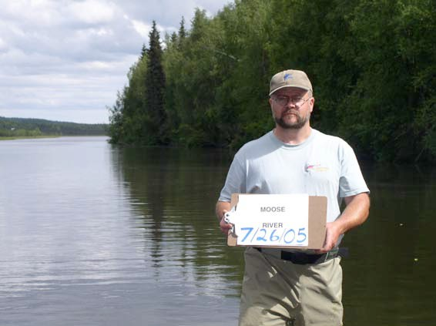
Figure 2.19: Moose River, 04/26/05

2.3.2.5 Funny River
This site is a Kenai River tributary and is located at 60.489963 N and -150.860982 W. Samples are typically collected 75 feet downstream of the bridge.
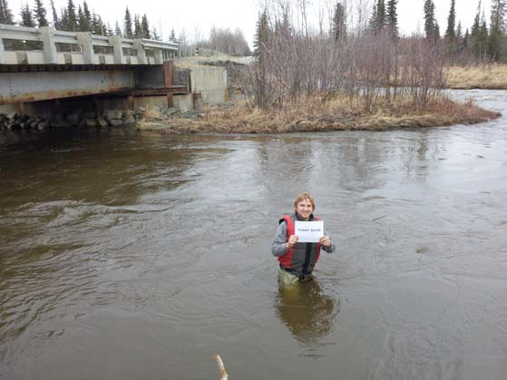
Figure 2.20: Funny River, 05/01/12

2.3.2.6 Soldotna Creek
This site is a Kenai River tributary and is located at 60.483364 N and -151.057656 W. Sampling typically occurs mid-channel.
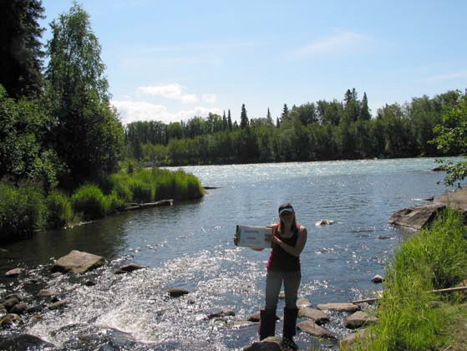
Figure 2.21: Soldotna Creek, 07/17/07

2.3.2.7 Slikok Creek
This site is a Kenai River tributary and is located at 60.482318 N and -151.127053 W. Samples are typically collected in the mid-channel of Slikok Creek.
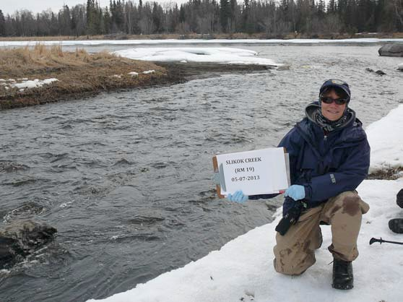
Figure 2.22: Slikok Creek, 05/07/13

2.3.2.8 Beaver Creek
This site is a Kenai River tributary and is located at 60.548029 N and -151.143240 W.
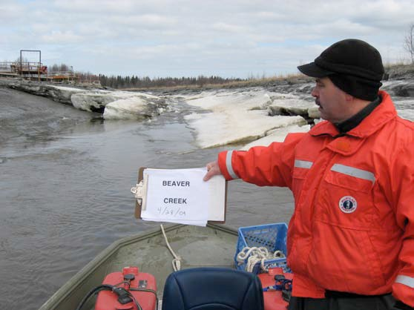
Figure 2.23: Beaver Creek, 04/28/09

2.3.2.9 No Name Creek
This site is a Kenai River tributary located at 60.550888 N and -151.268417 W. Samples are typically collected approximately 500 feet upstream of the confluence with the Kenai River, just upstream of the footbridge.
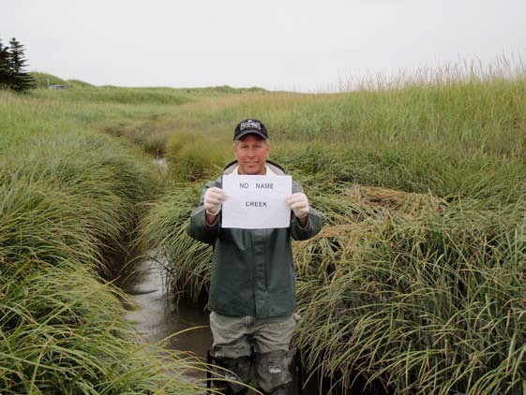
Figure 2.24: No Name Creek, 07/22/09

3. Methods
We collected water samples at 13 locations along the Kenai River mainstem and from eight tributaries near their confluence points (see Figure 2.2). These locations were selected by a technical working group in 1997 to represent diverse regions through the Kenai River watershed’s ambient water quality conditions. Sampling occurred in the spring and the summer each year beginning in summer 2000.
After a half‐day training session in the week prior, staff from governmental and non‐governmental agencies dispersed between 7:00 AM - 9:00 AM to sampling locations in teams of two or more to collect samples. All samples were collected on the same day, and the timing of the sampling coincided with an outgoing tide, near low tide, to reduce the potential of collecting saline water from Cook Inlet (see Appendix X for timing). Typically, the individual collecting the sample waded into the water until the water level was around two feet deep, and the sample was collected while facing upstream. If the individual collected the sample using a boat, the samples were collected from the bow while the boat faced upstream. The bottles were placed approximately one foot below the surface to collect the water samples and then preserved in a cooler for transportation to the laboratory. Beginning in spring 2002, two duplicate samples were collected for quality control. These procedures follow the protocols established in a Quality Assurance Project Plan (QAPP) that was originally approved by the ADEC in 2001 and later revised and approved by ADEC again in 2013, 2019, 2020. The QAPP was also reviewed and approved by the Region 10 Environmental Protection Agency office in 2023. The QAPP is available from Kenai Watershed Forum’s website.
We used the R programming language in Posit software for all analyses in this report, and generated this report using the Quarto publishing framework. It is hosted through Kenai Watershed Forum’s GitHub account. The report is available both as an online report here and is also downloadable in PDF form [when draft is complete].
In instances where data was reported as not detected the half of the method detection limit (MDL) or method reporting limit (MRL) was used to estimate the values and run the analysis. The MRL was used because during the early years of the project, the lab only provided this information and not the MDL.

4. Data Sourcing
We downloaded all results from the U.S. Water Quality Portal at https://www.waterqualitydata.us/ with the organization ID “Kenai Watershed Forum” on March 5, 2025. Results from this download populate the chapters throughout.
For an example of how data is prepared for submission to the Water Quality Portal, see Appendix A.
Warning: One or more parsing issues, call `problems()` on your data frame for details,
e.g.:
dat <- vroom(...)
problems(dat)
Warning: There was 1 warning in `mutate()`.
ℹ In argument: `ResultMeasureValue = as.numeric(ResultMeasureValue)`.
Caused by warning:
! NAs introduced by coercion

5. Data QA/QC
See the following:
- Appendix A: Data Review and Upload in this report provides an example of the QA/QC process used for data presented in this report, based off of procedures provided by the Alaska Department of Environmental Conservation.
- For QA/QC reviews of data other than year 2021, see https://github.com/Kenai-Watershed-Forum/kenai-river-wqx-qaqc
- For QA/QC review of data prior to 2013, see (Guerron Orejuela 2016)
Note on data in figures vs. tables in the following chapters:
- Boxplots: all data displayed visually in the boxplots in the following chapters has passed the QA/QC processes described in Appendix A: Data Review and Upload.
- Tables: each chapter contains a downloadable table of source data for the boxplots. Data that was flagged, or did not pass the QA/QC process described in Appendix A, is listed as “Rejected” in this column.
Note on further QA/QC efforts:
- As of 2026-03-28, we are focusing on synchronizing data from years 2014 - 2021 to the EPA Water Quality Portal. When that is complete, we will investigate if additional QA/QC may need to be performed on project data already existing in the Water Quality Portal. For data scientists, use the “Show Me the Code” button in the upper right corner to see a draft example of this process.
- In select cases, observations from 2000 - 2013 that were already in the WQP were visually identified as outliers (e.g. not realistic observations of in-situ conditions) and excluded from both the figures and tables in the following chapters. We justify this choice because prior to year 2022, the use of a field blank sample for total metals and dissolved metals was not in place, which can help identify and diagnose issues with field procedures contamination.
The observations designated as outliers are available for download here below, along with a rationale for why each decision was made.

6. Interpreting Boxplots

6.1 Interpreting Box Plots
Each of the following graphs display the sampling results for a specific parameter, such as arsenic. Within these graphs, a box and extending lines represent the results reported at each sampling site. A horizontal line within the box corresponds to the median of the data. The box contains 50% of the data and the vertical lines display the minimum and maximum values. All data points generating the boxplot are superimposed atop it (Figure 6.1).
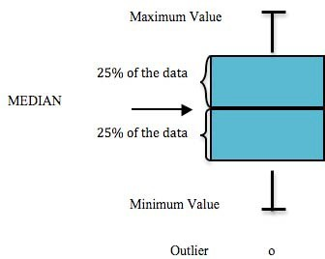
Figure 6.1: Components of a box plot
For further background on interpreting boxplots, see this figure from “R for Data Science” by (Wickham and Grolemund 2017).

7. Regulatory Limits
We calculated regulatory limits based on freshwater quality standards listed from state and/or federal regulatory agencies. Some regulatory threshold values are static and do not depend on additional environmental parameters, while some threshold values depend on local conditions like hardness, temperature, or pH.
We discuss how various parameters are assessed against standards below.

7.1 Metals

7.1.1 Metals with Static Regulatory Threshold Values
The metals parameters in the downloadable table below have static thresholds assigned.
Static regulatory values are represented as solid horizontal lines in the chapters that follow. (to do: show graphic example of values above horizontal line here)
# read in static reg values in wide format
static_metals_reg_vals <- read_xlsx("other/input/regulatory_limits/master_reg_limits.xlsx", sheet = "static_regulatory_values") %>%
filter(static_category == "static_metals",
standard_type %in% c("drinking_water","irrigation_water","stock_water")) %>%
remove_empty() %>%
select(parameter_baseline_name,standard_type,reg_value,reg_unit,agency,source) %>%
pivot_wider(names_from = standard_type, values_from = reg_value) %>%
rename(characteristic_name = parameter_baseline_name,
reg_agency = agency,
reg_agency_source = source)
# source formatted data
dat <- read.csv("other/output/analysis_format/baseline_export_format.csv")
# join static regulatory values to parameter results, and identify when/where exceedences occur
static_metals_thresholds <- left_join(dat,static_metals_reg_vals) %>%
mutate(drinking_water_exceed = case_when(
drinking_water >= result_measure_value ~ "Y")) |>
mutate(stock_water_exceed = case_when(
stock_water >= result_measure_value ~ "Y")) |>
mutate(irrigation_water_exceed = case_when(
irrigation_water >= result_measure_value ~ "Y"))

7.1.2 Metals with Hardness-Dependent Regulatory Values
Some regulatory values for metals are not simple static values, and are instead hardness-dependent (i.e. toxicity depends on calcium (Ca) and magnesium (Mg) concentrations). The metals parameters in the downloadable table below have hardness-dependent thresholds assigned.
# hardness-dependent criteria
# see page 29 of "Alaska Water Quality Criteria Manual for Toxic and other Deleterious Organic and Inorganic Substances" for parameters and formulas
# read in parameters which have hardness dependent criteria
diss_metals_hard_param <- read_excel("other/input/regulatory_limits/master_reg_limits.xlsx", skip = 1, sheet = "diss_metals_hard_parameters") %>%
remove_empty() %>%
select(-parameter_agency_name) %>%
filter(!is.na(characteristic_name),
!is.na(m_a))
# make downloadable list metals which have calculated parameters
dir <- "other/input/regulatory_limits/formatted_reg_vals/calculated_metals_list.csv"
write.csv(diss_metals_hard_param,dir, row.names = F)
embed_file(dir, text = "Download List of Metals with Hardness-Dependent Regulatory Threshold Values")

Hardness varies by site, by season, and with hydrologic conditions. We calculated hardness according to the following formula:
 | Hardness = 2.497(Total Calcium in mg/L) + 4.119(Total Magnesium in mg/L)
For sampling events with duplicate samples, we calculated average hardness. Note that some sampling events do not have calculated hardness values because total Ca and/or total Mg values were not available.

7.1.2.1 Acute and Chronic Hardness-Dependent Regulatory Threshold Values
Separate hardness-dependent standards often apply for acute vs. chronic metals toxicity.
We calculated hardness-dependent regulatory criteria based on formulas published on the Alaska Department of Environmental Conservation’s Water Quality Standards Section website (https://dec.alaska.gov/water/water-quality/standards/). The “Alaska Water Quality Criteria Manual for Toxic and other Deleterious Organic and Inorganic Substances” (2022) document, along with the “Inorganic Toxics Criteria Worksheet” provide parameter-specific formulas for many substances.
Hardness-dependent criteria is calculated from the following formula for metals in freshwater:
 | Acute (dissolved) = exp{mA[ln(hardness)]+ bA} (CF) Chronic (dissolved) = exp{mC [ln(hardness)] + bC} (CF)
where mA, bA, mC, and bC are numerical parameters specific to each substance, and CF is the conversion factor for acute vs. chronic criteria.
These values are graphically displayed in the following chapters. Rather than juxtaposed against static horizontal lines, instead they are highlighted by shape or color when the calculated threshold is exceeded; specific to that sampling event’s hardness conditions. See figure X for an example
(to do: show graphic example of values above threshold as colored asterisks here)
# possible general approach for graphic plots: export sheets of static and hardness-dependent results; use this to intake for all figures

7.2 Hydrocarbons
Note: the 2016 baseline report presents hydrocarbon data chapters structured as follows:
- Diesel Range Organics
- Gasoline Range Organics
- Residual Range Organics
However, as of 2026-03-28 it is unclear which specific hydrocarbon parameters, or grouped sums of hydrocarbon parameters, have equivalent names in our data set downloaded from the EPA WQX. As a result, in this report we will structure data to simply assess BTEX values against the ADEC regulatory standard. There may be federal standards that also apply to hydrocarbons, to be addressed later.

7.2.1 Total BTEX
Total aromatic hydrocarbons (TAH) means the sum of the following volatile monoaromatic hydrocarbon compounds: benzene, toluene, ethylbenzene, and the xylene isomers, commonly called BTEX. The Alaska Dept of Environmental Conversation describes a maximum static regulatory value of 10 ug/l BTEX.
For each sampling event with available hydrocarbons data, we calculated the sum of the parameters that compose BTEX and compared them to a static threshold value.
To prepare our existing data to be assessed against this standard, we addressed the following issues:
- In some cases, BTEX data is quantified as a total mixture (sum of all benzene, toluene, ethylbenzene, and the xylene isomers). In other cases, the individual substances are instead quantified separately.
- In yet other cases, both the values of individual components of BTEX and the total mixture values are reported separately.
- To create a consistent parameter, we summed the total quantities of benzene, toluene, ethylbenzene, and xylene by unique sampling event (unique location/time) when it had not already been reported as such.
- In some cases, multiple isomers of the same hydrocarbon are quantified (e.g. o-xylene vs m,p-xylene). In these cases, we summed the total quantity of the substance for all isomers.

7.3 Nutrients (Nitrogen and Phosphorus)
The following nurtient parameters names are present in the dataset:
- “Phosphorus”
- “Inorganic nitrogen (nitrate and nitrite)”
- “Nitrate”
The previous reports on these data (Guerron Orejuela 2016 and McCard 2007) use only the terms “Nitrate” and “Phosphorus” to describe nutrients.
In our dataset, we have 24 observations of “Nitrate” and 592 observations of “Inorganic nitrogen (nitrate and nitrite).” Both of these parameters are reported to use the identical lab analytical method (4500-NO3(E)). For this report, will treat the two parameter names as indistinguishable, and data appears in the figure as such.

7.4 Fecal Coliform Bacteria
A variety of fecal coliform standards are described in ADEC standards (18 AAC 70). Fecal coliform bacteria may be assessed against criteria in two ways:
- Instantaneous point values, where criteria are exceeded if 10% of samples are above threshold within a 30 day period
- Geometic mean within a 30-day period
In this project, we collect only single samples on single days for each site. Thus, data are not structured to be assessed against existing state standards. In this report, we display two fixed threshold values for a) harvesting aquatic life and b) secondary recreation (contact with water), but it should be notes that single values above these lines do not represent regulatory exceedences.
- helpful data to understand where/when more monitoring is needed
- important to help understand spatial trends
Additional sampling beyond this project is needed to reasonably characterize bacteria conditions in the Kenai River, and several major efforts between 2010 - 2020 contributed to this effort. For more information and detailed reports on Kenai River bacteria monitoring, visit https://www.kenaiwatershed.org/other-water-research/ and click on “Bacteria Monitoring.”

7.5 Total Suspended Solids
Alaska Department of Environmental Conservation (ADEC) standards require that fine sediment in the range of 0.1 mm to 4.0 mm cannot increase over 5% by weight higher than natural conditions in gravel beds used by anadromous or resident fish for spawning, and the sediment can never exceed a maximum of 30% by weight in freshwater for the growth and propagation of fish, shellfish, other aquatic life, and wildlife (ADEC 2025). More generally, the ADEC standard also states that the amount of deposited or suspended sediment cannot cause adverse effects on aquatic life, including their habitat and reproduction.
As such, there is no fixed standard for total suspended solids. Data from this project is best interpreted by either examining long term trends and/or evaluating results in the context of data that provide evidence for “natural conditions.”

7.6 Other Parameters

The following parameters are also monitored for each sampling event:
- pH - The ADEC standard for pH maintains that freshwater may not have a pH less than 6.5 or greater than 8.5 for the growth and propagation of fish, shellfish, other aquatic life and wildlife.
- Water Temperature - See https://aktemp.uaa.alaska.edu/
- Turbidity - see chapter on turbidity for details
- Dissolved Oxygen - monitored, but not reported in 2016 study

8. Arsenic
From 2016 report:
Natural sources of arsenic in the Cook Inlet Basin include volcanic ash, glaciation, and mineral deposits. Only a minimal contribution of arsenic results from human activities like wood preservation (Glass and Frenzel, 2001). Arsenic is naturally present as a compound in rocks within the Kenai River Watershed, and as a dissolved metal, it can be acutely or chronically toxic to fish (Glass, 1999). The Alaska Department of Environmental Conservation (ADEC) and the United States Environmental Protection Agency (USEPA) have set the standard at 150 micrograms per liter (µg/L) for freshwater aquatic life chronically exposed to arsenic and 10 micrograms per liter (µg/L) for drinking water (Appendix X) (USEPA, 2014; ADEC, 2008).
None of the samples exceeded the Alaska or federal standard for freshwater aquatic life at any sampling location in spring or summer. The highest level detected in the mainstem was 46.5 µg/L at Mile 1.5 in May 2007, and arsenic was not detected on many occasions below the method detection limit (MDL) of 0.25 µg/L (Table 6). In the Kenai River mainstem, Mile 1.5 had the highest median level in the spring event and summer monitoring event, followed by Mile 6.5 in the spring event and Mile 23 during the summer monitoring event (figures X & X). In the mainstem, higher arsenic levels occurred in the spring samples, while the tributaries levels were higher during the summer with more detected levels between the years 2007-2014 than any of the previous years. (Tables X & X)
The highest concentration on the mainstem occurred at Mile 1.5 where arsenic was detected on every sampling event after 2005, while arsenic was detected on all sampling dates at Beaver Creek, Soldotna Creek, and Moose River. The concentrations of arsenic ranged from a high of 12.8 µg/L in Soldotna Creek in summer 2014 to below the MDL of 0.25 µg/L in many locations. Of the tributaries, Soldotna Creek had the highest median level, followed by Moose River and then Beaver Creek in summer and Soldotna, Beaver and Moose in spring. No Name Creek had the fewest incidences of arsenic detection of all the tributaries. (Tables X & X)
When comparing the arsenic levels to the Alaska Department of Environmental Conservation standards for drinking water, the main stem at Mile 1.5 is the only station that presents multiple exceedances. All exceedances took place during the spring sampling events. (Tables X & X)
Concentrations of arsenic are generally lower in surface streams than in groundwater, which is typically the source of drinking water (Glass and Frenzel, 2001). The USEPA set the criterion for arsenic in drinking water at 10 µg/L because arsenic has been linked to cancer, skin damage, and circulatory problems (USEPA, 2003). Although the levels of arsenic reported in this study do not exceed the national criterion for the health of an aquatic community in freshwater, groundwater may contain concentrations that are hazardous to human health, and all sources of drinking water should be tested for arsenic.
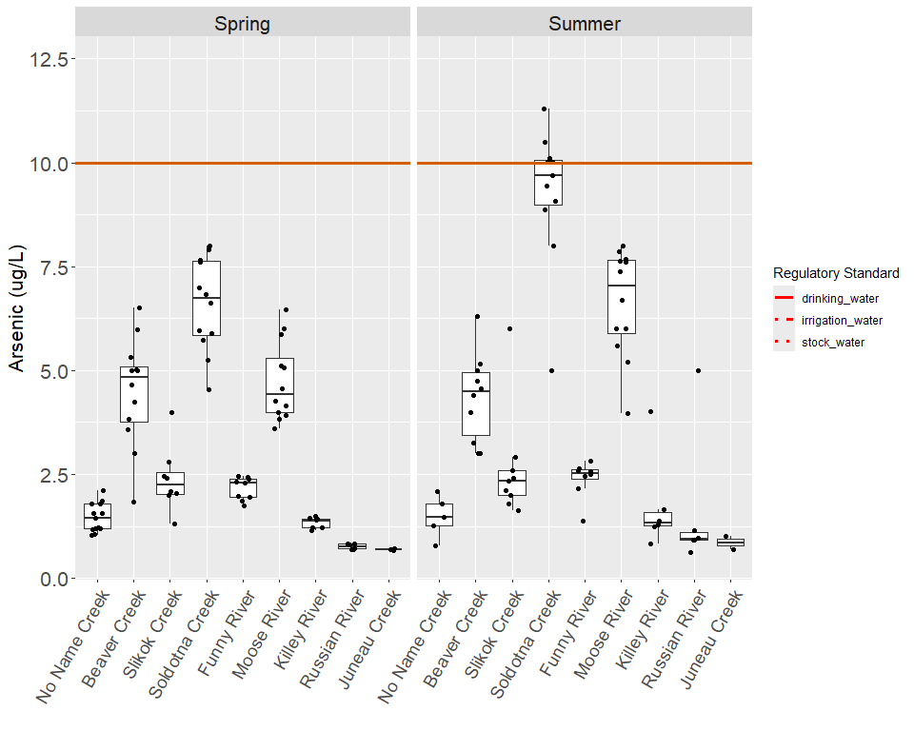
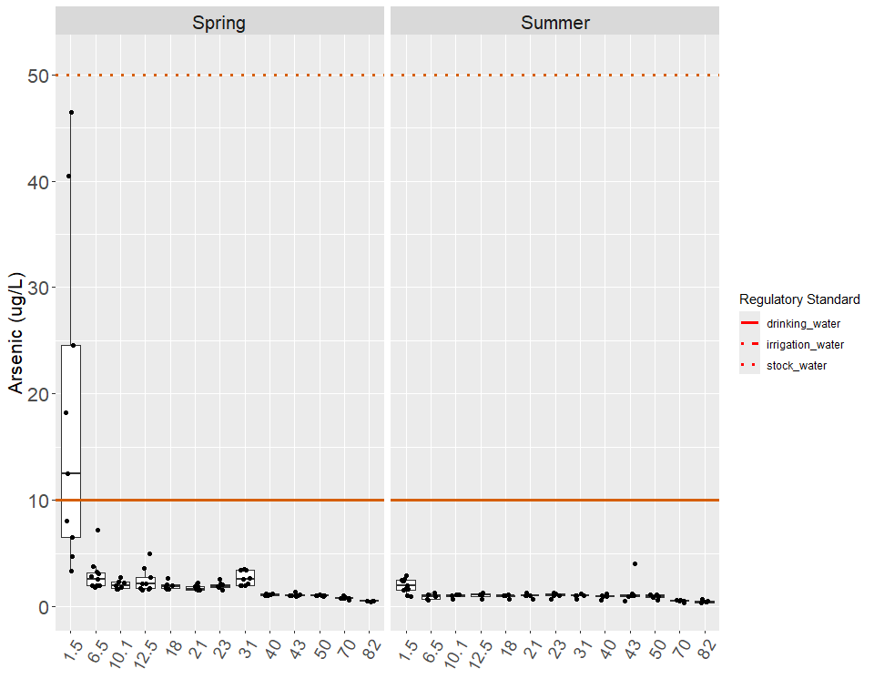
Regulatory thresholds for Arsenic (hardness-dependent ranges reflect observed hardness across all dataset years)
Standard Type | Value | Unit | Regulatory Authority
Drinking water (MCL) | 10 | µg/L | USEPA
Stock water | 50 | µg/L | ADEC
Irrigation water | 100 | µg/L | ADEC

9. Cadmium
From 2016 report:
Cadmium is a rare elemental metal that can occur naturally in freshwater at concentrations of less than 0.1 μg/L, but at slightly increased concentrations, it can be toxic to aquatic life (USEPA, 2001). Additional cadmium can enter the hydrologic cycle as a component of fertilizer, pesticide, pigment, and as a result of iron and steel production, coal combustion, and mining waste (USEPA, 2001). The ADEC and the USEPA have set the standard for cadmium at a range of 0.0650 μg/L to 0.64 μg/L, depending on hardness, for chronically exposed freshwater aquatic life (Appendix 2) (USEPA, 2014; ADEC, 2008).
In the mainstem, concentrations of cadmium ranged from a high of 8 μg/L at Mile 21 in summer 2000 to the lowest levels that were below the MDL of 0.062 μg/L that occurred in multiple locations. In the Kenai River mainstem, cadmium samples at Mile 21 and Mile 82 exceeded the standard on one occasion each. (Table 7)
The highest level of cadmium ever detected in the tributaries was 63 μg/L at Soldotna Creek in summer 2002, and the lowest was below the MDL of 0.062 μg/L. Cadmium was detected once above the standard in Soldotna Creek and Slikok Creek, and all other tributary samples did not exceed the standard. (Table 33)
Since so few cadmium samples were detected, trends were difficult to determine and should be interpreted with caution. In spring, cadmium was only reported four times, in contrast to summer samples in which it was reported ten times. In April of 2001, 2002, 2003, 2004, 2005 and summer 2001 through 2005, the method reporting limits (MRL) were mainly higher than the standard, so it is unknown whether these samples exceeded the standard. (Tables 7 & 33)
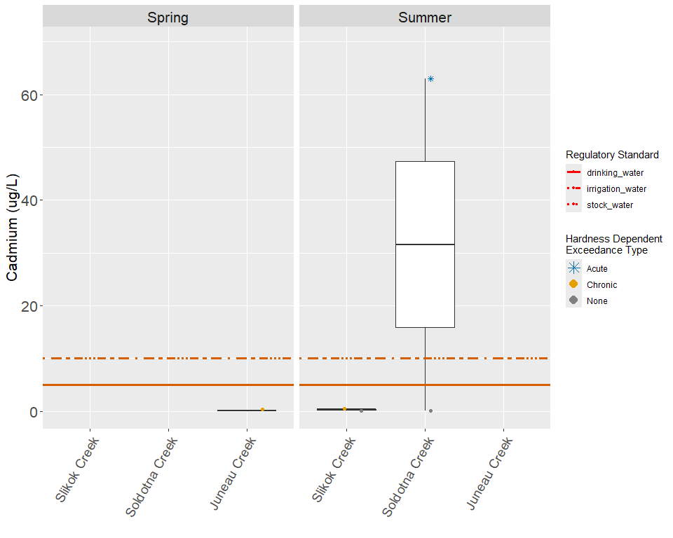
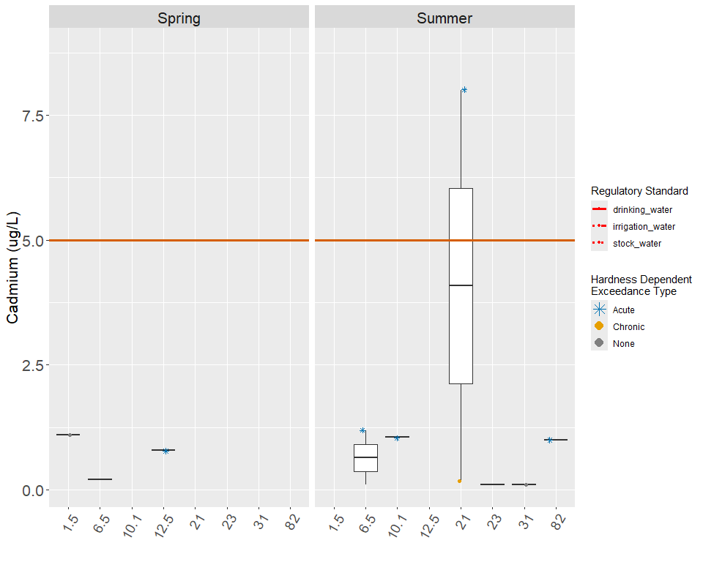
Regulatory thresholds for Cadmium (hardness-dependent ranges reflect observed hardness across all dataset years)
Standard Type | Value | Unit | Regulatory Authority
Drinking water (MCL) | 5 | µg/L | USEPA
Stock water | 10 | µg/L | ADEC
Irrigation water | 10 | µg/L | ADEC
Aquatic life – acute (hardness-dependent) | 0.128 – 51.3 | µg/L | USEPA
Aquatic life – chronic (hardness-dependent) | 0.0342 – 2.48 | µg/L | USEPA

10. Chromium
From 2016 report:
In rivers and streams, chromium is an elemental metal that typically exists as hexavalent or trivalent chromium (USEPA, 1980a). Non-natural sources of chromium salts include the metal finishing industry, textile manufacturing, leather tanning, paint, fungicides, and wood preservatives (USEPA, 1980a). At a concentration of 21 µg/L of hexavalent chromium, river algae cannot photosynthesize, and the growth in weight of Chinook salmon can be reduced by approximately ten percent at a concentration of 16 µg/L (USEPA, 1980a). Consequently, the ADEC and the USEPA have set the standard for hexavalent chromium at 11 µg/L and at a range of 15.52 µg/L to 230.67 µg/L for trivalent chromium, depending on hardness, for chronically exposed freshwater aquatic life (Appendix 2) (USEPA, 2014; ADEC, 2008). The standard for hexavalent chromium is not displayed on the following graphs because the analysis did not distinguish between trivalent and hexavalent chromium.
None of the medians for the mainstem or the tributaries exceeded the freshwater aquatic life standard for hexavalent or trivalent chromium, although single samples did detect concentrations above the hexavalent chromium standard at Mile 6.5, Mile 10.1, Mile 21, and Beaver Creek. The standard for trivalent chromium was not exceeded at any site along the mainstem or tributaries during any sampling event. The highest concentration of chromium in the mainstem was 25 µg/L at Mile 21 in summer 2000, and the lowest levels occurred below the MDL of 0.36 µg/L. In the mainstem the locations with a median above 1 µg/L where Mile 1.5 both in spring and summer and Mile 6.5 in spring only. (Tables 8 & 34)
Chromium concentrations in the tributaries ranged from a high of 16.4 µg/L at Beaver Creek in summer 2006 to less than the MDL of 0.36 µg/L. The medians of chromium in the tributaries during both the spring and summer events were all below 1 µg/L. In the tributaries, higher levels of chromium were reported in the summer compared to the spring, while a seasonal trend was difficult to distinguish in the mainstem. (Figure 36-39)
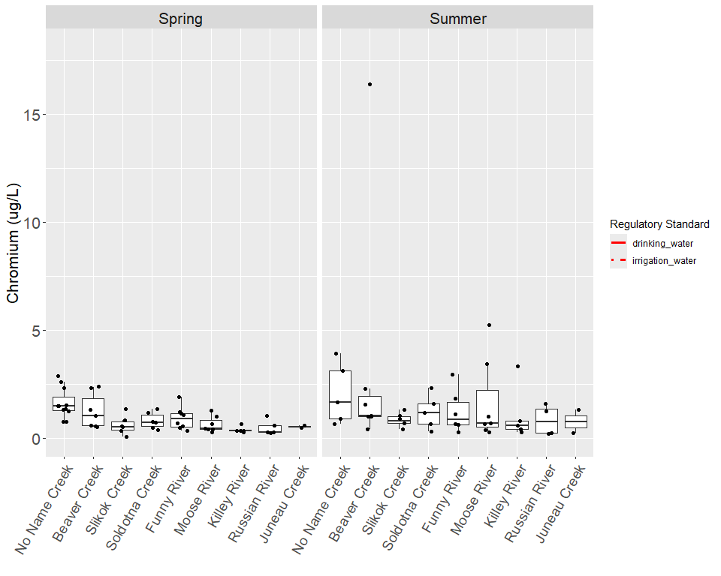
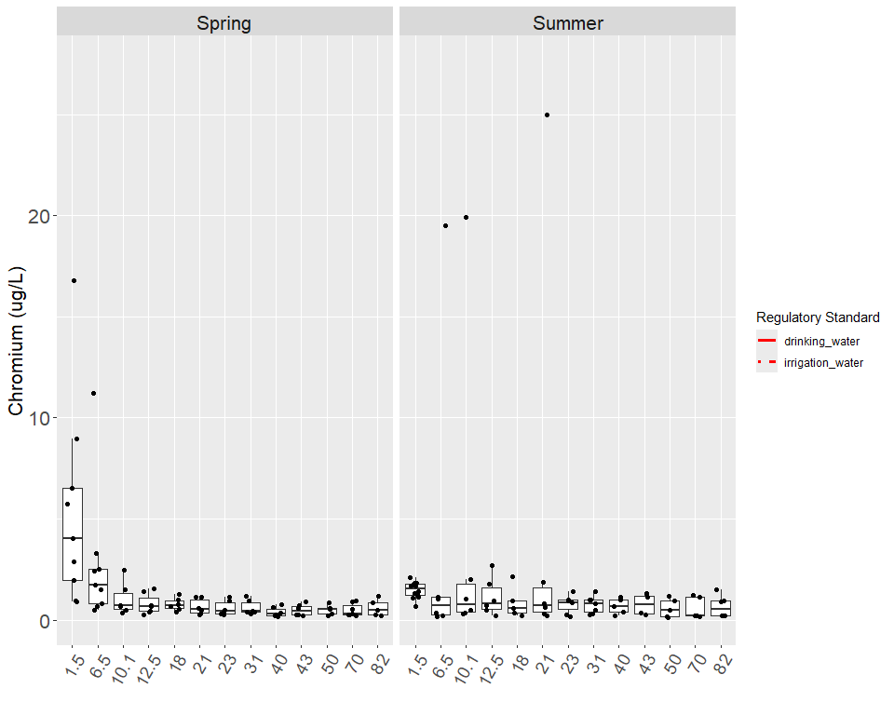
Regulatory thresholds for Chromium (hardness-dependent ranges reflect observed hardness across all dataset years)
Standard Type | Value | Unit | Regulatory Authority
Drinking water (MCL) | 100 | µg/L | USEPA
Irrigation water | 100 | µg/L | ADEC
Aquatic life – acute (hardness-dependent) | 178 – 27900 | µg/L | USEPA
Aquatic life – chronic (hardness-dependent) | 8.5 – 1330 | µg/L | USEPA

11. Copper
Typically present in surface waters, naturally low concentrations of copper are essential as micronutrients for plants and animals, but elevated levels can be toxic to certain aquatic species (USEPA, 2007). Concentrations of copper can increase in surface waters due to discharges from mining, the leather industry, electrical equipment, and fabricated metal products (USEPA, 2007). Copper is present in the brake pads of vehicles and can enter surface waters in storm water runoff (USEPA, 2015). The standard for copper set by the ADEC, ranges from 1.75 μg/L to 29.28 μg/L, depending on hardness, for chronic exposure to aquatic life in freshwater (see Appendix X) (ADEC 2008).
The highest concentration of copper in the mainstem was reported at _____ μg/L at [site] in [season/year], and the lowest levels were below the MDL of ____ μg/L. In the summer, ____ exceedances occurred at [sites], and copper concentrations exceeded the criteria during individual sampling dates at [sites]. Higher levels occurred ____, while the lowest concentrations were detected at ____. [Were exceedances were recorded for the mainstem during the sampling events in spring/summer?]. Copper concentrations in the tributaries ranged from ___ μg/L in the [site/year] to below the MDL of ___ μg/L that occurred in many locations during this project. Exceedances in the spring occurred at….. Exceedances in the summer occurred at ….
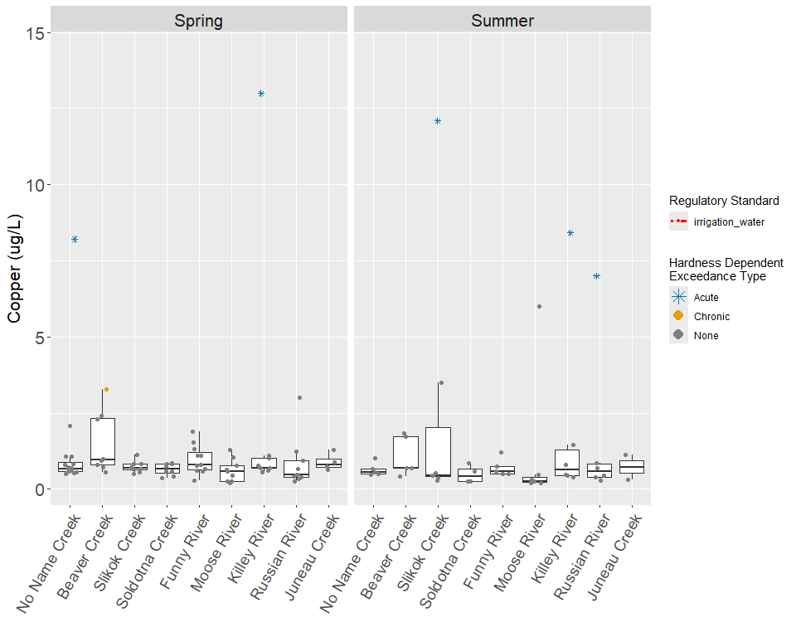
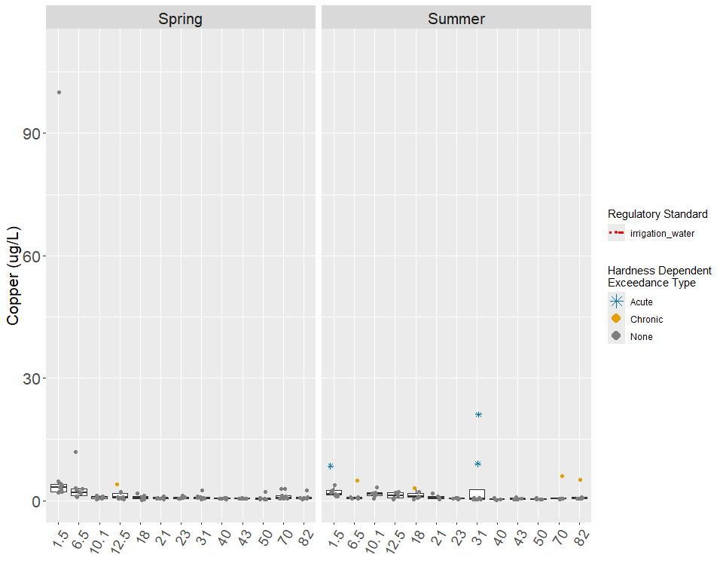
Regulatory thresholds for Copper (hardness-dependent ranges reflect observed hardness across all dataset years)
Standard Type | Value | Unit | Regulatory Authority
Irrigation water | 200 | µg/L | ADEC
Aquatic life – acute (hardness-dependent) | 0.975 – 327 | µg/L | USEPA
Aquatic life – chronic (hardness-dependent) | 0.833 – 162 | µg/L | USEPA

12. Lead
Metallic lead and lead minerals are not classified as soluble in water, but they can be solubilized by certain acids, and a selection of industrial lead compounds are water soluble upon production (USEPA, 1980b). Lead is a component in electroplating, metallurgy, construction materials, plastic, and electronic equipment, and it can enter surface water through precipitation, dust, street runoff, and wastewater discharges (USEPA, 1980b). Exposure to lead can cause delayed embryonic development, reduced growth, and suppressed reproduction in fish, and spinal deformities in rainbow trout fry (USEPA, 1980b). Determined by the ADEC and the USEPA, the standard for lead ranges from 0.300 to 10.94 μg/L, depending on hardness, for the chronic exposure of aquatic life in freshwater (Appendix X) (ADEC, 2008; USEPA, 2014).
The highest concentration of lead in the mainstem was 468 μg/L and was sampled at Mile 31 during summer 2005, and the lowest levels occurred below the MDL of 0.030 μg/L at many locations in the spring and the summer of the sampling years. Exceedances occurred mainly in the summer, when lead exceeded the criteria twice at Mile 21, and once at Mile 1.5, Mile 6.5, Mile 10.1, Mile 12.5, Mile 31, and Mile 82, Mile 1.5 and Mile 6.5 exhibited the most instances of detection in the spring and the summer. At Mile 40, Mile 43 and Mile 74 (Russian River) no concentrations of lead were ever reported. Only two exceedances where recorded during the spring sampling events, once at Mile 6.5 and once at Mile 10 (Beaver Creek) (Table X).
The concentration of lead in the tributaries ranged from a high of 3.92 μg/L at Beaver Creek in summer 2006, and the lowest levels were below the MDL of 0.030 μg/L at many locations in the spring and summer sampling events. The Killey River and Juneau Creek each exceeded the criteria on one occasion in the summer of 2004 and 2013 respectively. Beaver Creek had two exceedances, one in the spring of 2011 and one in the summer of 2006. No lead was ever reported in Russian River. The MDLs were higher than the standard from summer 2000 through summer 2003 and summer 2005, so it is unknown whether exceedances occurred in many of these samples (Table X).
A trend analysis was conducted using the average and median values for all data collected during the time period between years 2000-2014. The concentrations of lead throughout the entire Kenai River are relatively high in the lower river and decrease as you move towards the upper river (Figure X and Figure X). A similar analysis was done for each sampling station at the Kenai River with results showing that no lead was found in most of the sampling stations before year 2005, after year 2005 when lead has been found it shows a decrease in concentration through time. It is important to note that not every station has an actual reading and in many cases there are very few readings or non- at all.
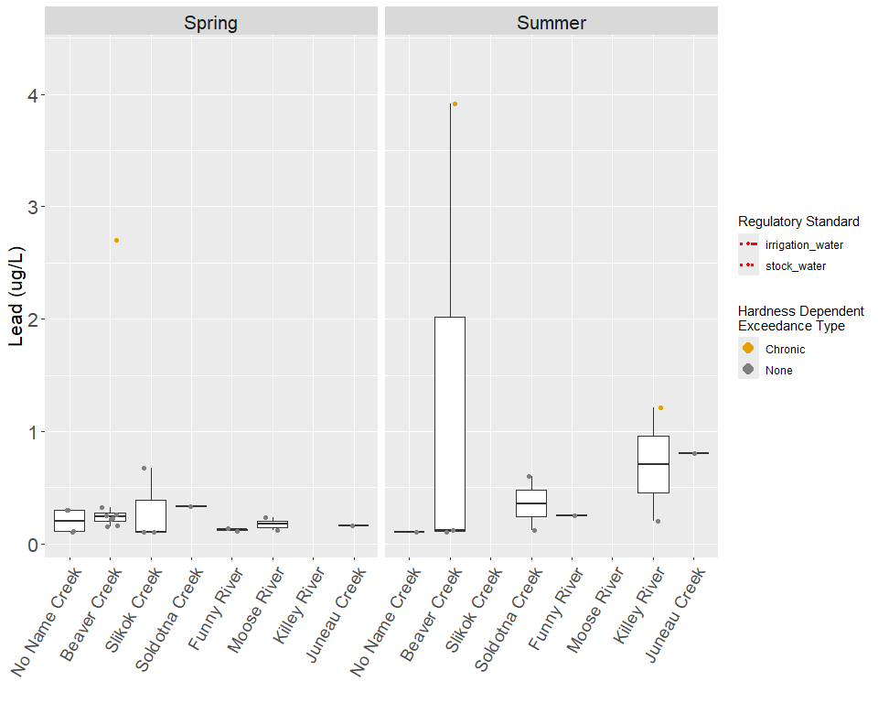
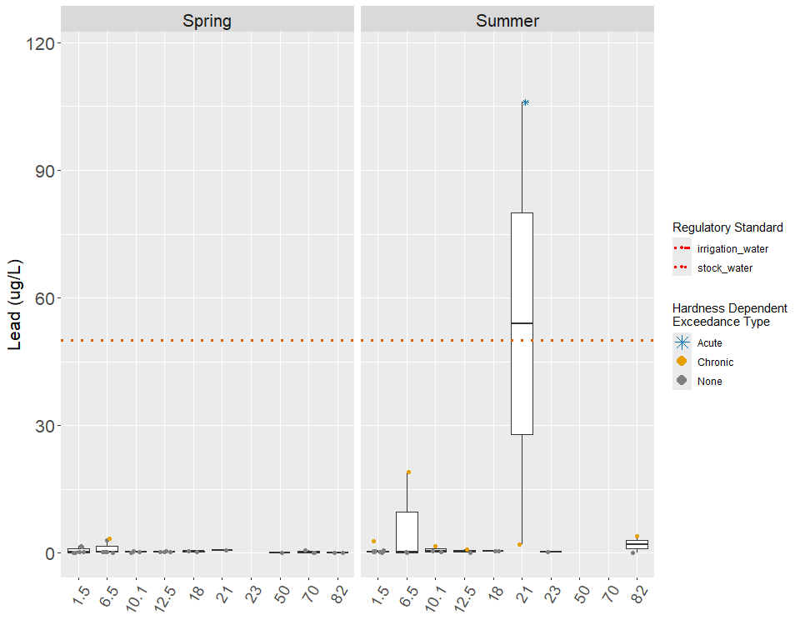
Regulatory thresholds for Lead (hardness-dependent ranges reflect observed hardness across all dataset years)
Standard Type | Value | Unit | Regulatory Authority
Stock water | 50 | µg/L | ADEC
Irrigation water | 5000 | µg/L | ADEC
Aquatic life – acute (hardness-dependent) | 2.68 – 1750 | µg/L | USEPA
Aquatic life – chronic (hardness-dependent) | 0.105 – 68.2 | µg/L | USEPA

13. Zinc
Zinc enters surface water naturally through the weathering of bedrock and is an essential micronutrient for all plants and animals (USEPA, 1987). Additional zinc can enter surface water because it is widely used for galvanizing steel, as an alloy, in rubber, and in paint (USEPA, 1987). More recent studies suggest that higher concentrations of Zinc in suburban areas can be caused by tire wear (USGS, 2012). The ADEC and the USEPA have set the standard for zinc ranging from 23.4 to 382.4 μg/L, depending on hardness, for the chronic exposure of freshwater aquatic life (see Appendix X) (ADEC, 2008; USEPA, 2014).
The highest level recorded in the mainstem was 2900 μg/L in summer 2000 at Mile 21, and the lowest level occurred at Mile 31 in summer 2006 with a concentration of 0.521 μg/L. In the spring, exceedances occurred at every sampling station except Mile 40 and Mile 50. More exceedances in the mainstem occurred during the summer with eight exceedances at Mile 10.1, seven exceedances at Mile 18, five exceedances at both Mile 6.5 and Mile 12.5. Mile 21 and Mile 23 present four exceedances. Mile 1.5 and Mile 31 present three exceedances. Miles 40, 50, 70 and 82 all present two exceedances. Mile 40 one exceedance (Table 11). The Kenai River estuary had higher median concentrations than the rest of the river in spring, during the summer events this pattern was not clear. Relatively higher medians also occurred at Mile 31, Mile 21, and Mile 10.1 in the summer (Figure X & X).
Zinc concentrations in the tributaries ranged from a high of 247 μg/L in Beaver Creek during spring 2011 to a low of 0.462 μg/L in Russian River during spring 2009. In the spring, exceedances of the criteria occurred eight times at No Name Creek, Beaver Creek and Slikok Creek. Seven times at Funny River, four at Soldotna Creek And Killey River one at Moose River and Russian River. In the other tributaries, exceedances occurred twice at Beaver Creek and Funny River and once at Soldotna Creek and the Killey River during the spring. In the summer, exceedances occurred six times at Killey River, four times at No Name Creek and Beaver Creek, once at Slikok Creek, Russian River and Juneau Creek. Beaver Creek had the highest median of all the tributaries, with No Name Creek and Funny River close behind in the spring (Table X). In the summer No Name Creek had the highest median of all the tributaries, with Beaver Creek and Soldotna Creek close behind. In the tributaries, zinc concentrations and the number of exceedances were greater in the spring. In the spring and the summer of 2003, the MRL of 50 μg/L was higher than most of the standards, so incidences of exceedance are unknown in many of these samples (Figure X & X).
A trend analysis was conducted using the average and median values for all data collected during the time period between years 2000-2014. The concentrations of zinc throughout the entire Kenai River show a relative decrease from Mile 1.5 to Mile 50 and a relative increase at Mile 70 and Mile 82. This pattern is visible during both the spring and summer sampling events (Figure X-X). A similar analysis was run for each sampling station at the Kenai River. During the spring all the stations present a relative decrease in zinc concentrations until year 2008, after that a low increase is apparent at all stations. For the summer the same general trend is visible, with a stronger increase pattern after year 2008 (Figure X-X)
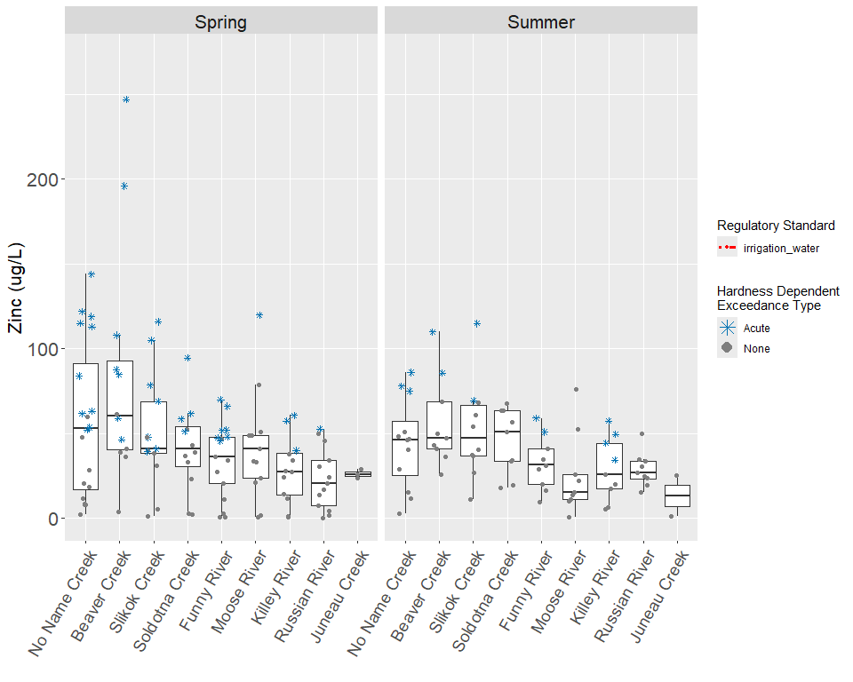
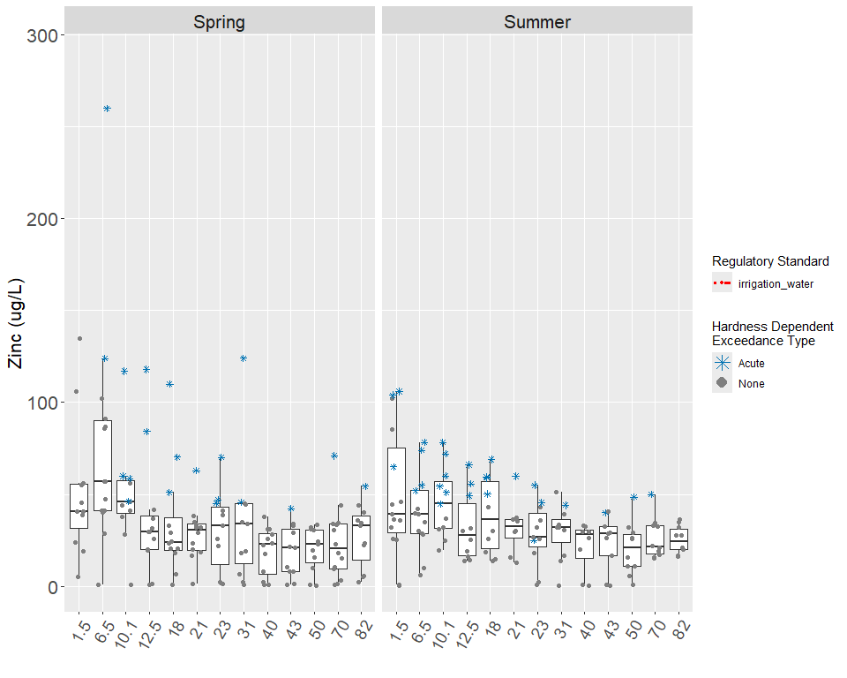
Regulatory thresholds for Zinc (hardness-dependent ranges reflect observed hardness across all dataset years)
Standard Type | Value | Unit | Regulatory Authority
Irrigation water | 2000 | µg/L | ADEC
Aquatic life – acute (hardness-dependent) | 10.9 – 2040 | µg/L | USEPA
Aquatic life – chronic (hardness-dependent) | 10.9 – 2040 | µg/L | USEPA

14. Calcium
From the 2016 report:
Both plants and animals require calcium as an essential element, and calcium is important to water quality because it is directly linked to the hardness of water (Glass, 2001). There is not an ADEC or USEPA standard for the chronic exposure of freshwater aquatic life to calcium.
The highest value in the mainstem occurred during spring 2002 at Mile 1.5 with a concentration of 174 mg/L, and the lowest value was 0.447 mg/L at Mile 43 in summer 2010 (Table 12). Relatively high medians in the spring and the summer occurred at Mile 1.5, Mile 6.5, Mile 70, and Mile 82. In the spring and in the summer, the low median at Mile 43 may be linked to the low calcium concentration in the Killey River. Russian River had high levels of calcium and could be the cause of elevated concentrations at Mile 70. In the mainstem, calcium levels were relatively higher in spring than in summer (Figures 88 & 89).
In the tributaries, the lowest concentration was 3 mg/L sampled from the No Name Creek during May 2013, and the highest concentration occurred in the Moose River at 25.7 mg/L during summer 2004 (Table 38). In the spring, the Russian River, Moose River and Juneau Creek had relatively high medians, and Slikok Creek had a relatively low median (Figure 90). In the summer, the Moose River, Soldotna Creek and Beaver Creek had relatively high medians, and the Killey River had a relatively low median (Figure 91). In the spring, most of the tributaries had concentrations lower than the mainstem, but during the summer, most of the tributaries had higher levels of calcium than the mainstem. The tributaries had higher levels of calcium in the summer than in the spring, excluding Russian River, the Killey River and Juneau Creek. Beaver Creek exhibited the largest seasonal difference in medians, changing from 9.25 mg/L in the spring to 18.6 mg/L in the summer (Figures 90 & 91).
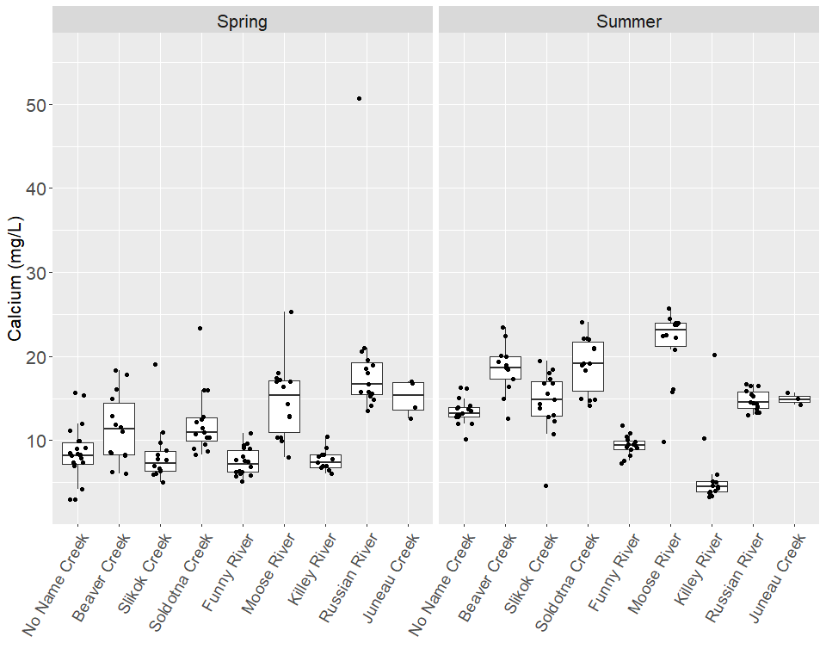
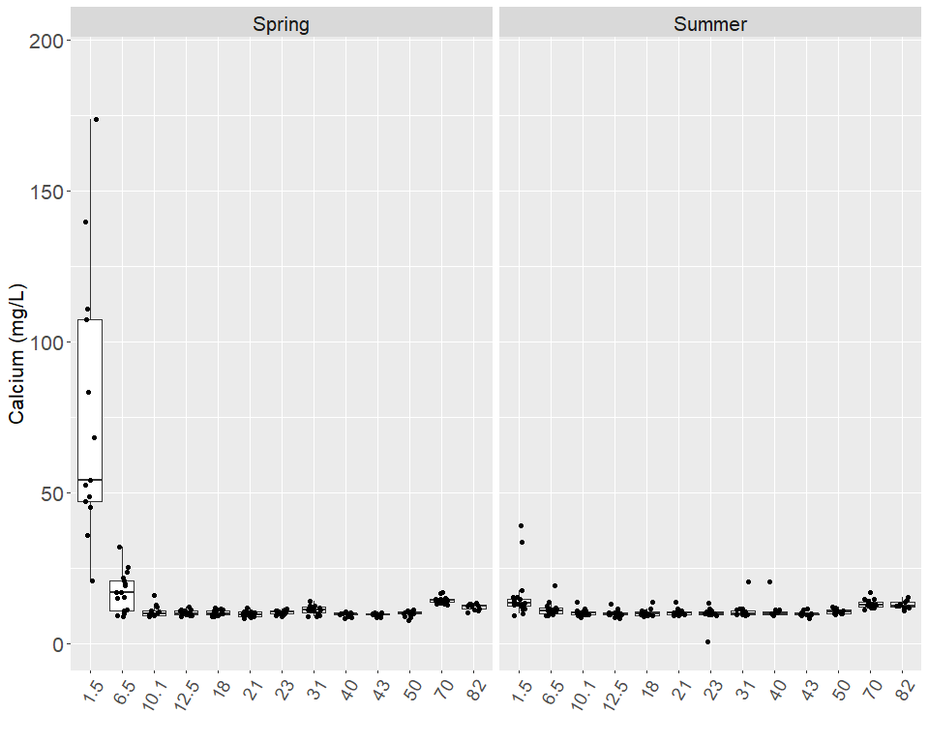

15. Iron
Naturally present in many rocks and soils, iron is required by plants and animals for metabolism (Glass, 2001). Sources of detrimental levels of iron are industrial waste, mining, and iron-rich groundwater, and when high concentrations of iron react with dissolved oxygen, precipitates form that can harm salmon eggs and other aquatic life (USEPA, 1976). The ADEC and the USEPA have set the iron standard for the chronic exposure of freshwater aquatic life at 1 mg/L (see Appendix X) (ADEC, 2008; USEPA, 2014).
In the mainstem, the highest concentration of iron was 128 mg/L, which occurred at Mile 6.5 during spring 2006, and 0.03 mg/L was the lowest concentration that occurred at Mile 70 during spring 2013 (Table X). Mile 1.5 and Mile 6.5 had the highest medians during the spring and the summer (Figures X & X). Mile 1.5 and Mile 6.5 both exceeded the standard in the majority of samples (Table 13). In the spring, the median at Mile 10.1 also exceeded the standard, but the medians from all other mainstem locations were below the standard in both the spring and the summer (Figures X & X). There was a general upward trend in iron concentration from Kenai Lake to the estuary, especially in the summer.
The concentrations in the tributaries ranged from a high of 20.5 mg/L in Beaver Creek in spring 2006 to Russian River, which had the lowest concentration at below the MDL of 0.0027 mg/L (Table X). No Name Creek, Beaver Creek, Slikok Creek, Soldotna Creek, Funny River and Moose River all had medians exceeding the standard in Spring (Figure 94). No Name Creek and Beaver Creek had medians exceeding the standards during summer (Figure X). Russian River had the lowest iron levels with most of the samples reported below the MDL or MRL. In both the tributaries and the mainstem, iron levels were higher in the spring than in the summer (Figures X-X).
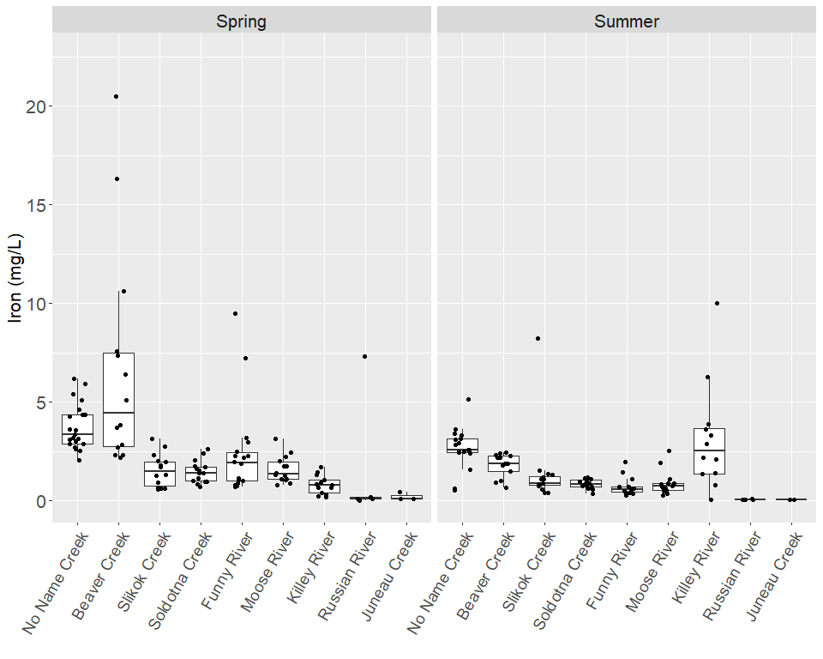
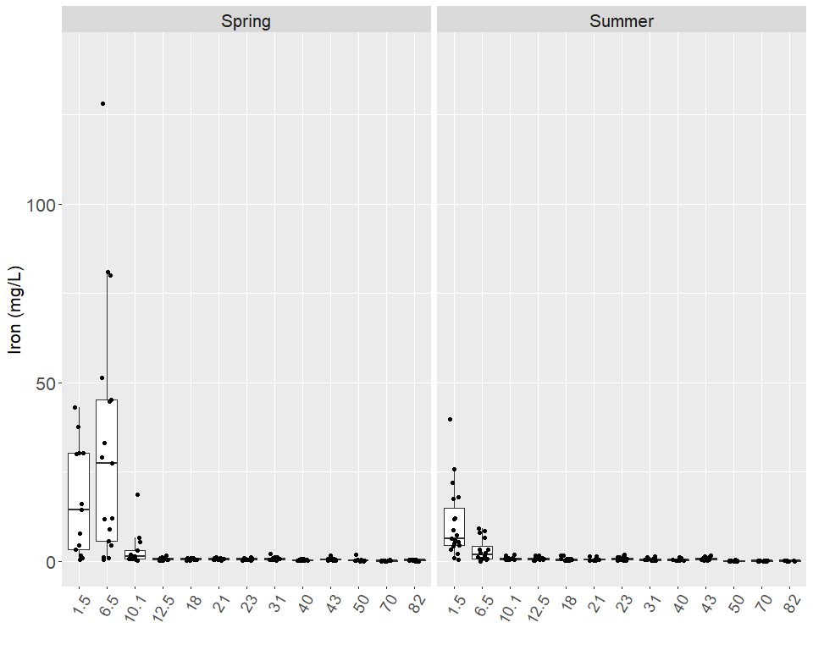

16. Magnesium
As an essential element, magnesium concentrations can significantly impact plants and animals, and magnesium also influences water quality because it contributes to hardness (Glass, 2001). Neither the USEPA nor the ADEC has set a water quality standard for magnesium concentrations in freshwater for chronically exposed aquatic life.
In the mainstem, the highest concentration of magnesium was 582 mg/L and occurred at Mile 1.5 during spring 2011, while the lowest level was 0.729 mg/L at Mile 50 in summer 2001 (Table X). In both the spring and the summer, Mile 1.5 had the highest median followed by Mile 6.5. There was a general upward trend in magnesium levels from Kenai Lake to the estuary in both the spring and the summer. Magnesium levels were higher upstream of Skilak Lake, and at the outlet, magnesium dropped to the lowest levels recorded in the watershed. In the mainstem, magnesium concentrations were higher in the spring than in the summer (Figures X & X).
The concentrations in the tributaries ranged from the high of 21.4 mg/L in spring 2010 at No Name Creek to 0.746 mg/L in spring 2004 at the Killey River (Table X). The Killey River, Russian River and Juneau Creek had low medians in comparison to the other tributaries like Soldotna Creek, which had the highest median during the summer. Excluding the estuary, the tributaries generally had higher levels of magnesium than the mainstem. In the tributaries, median concentrations were higher in the summer than in the spring, excluding Beaver Creek and Russian River (Figures X & X).
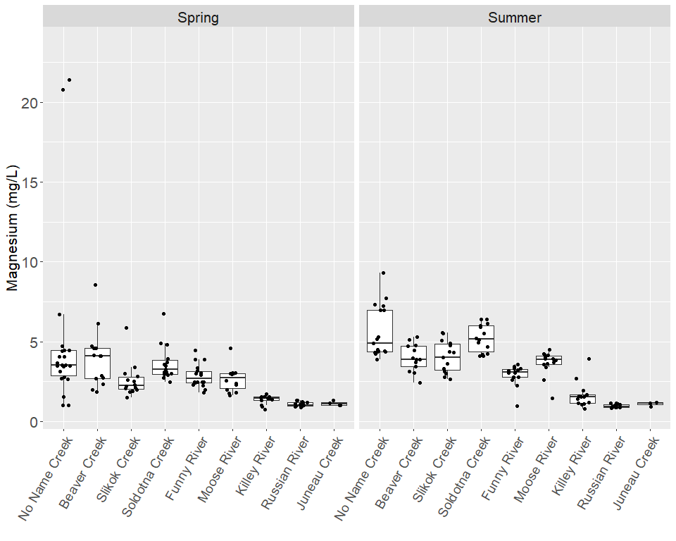
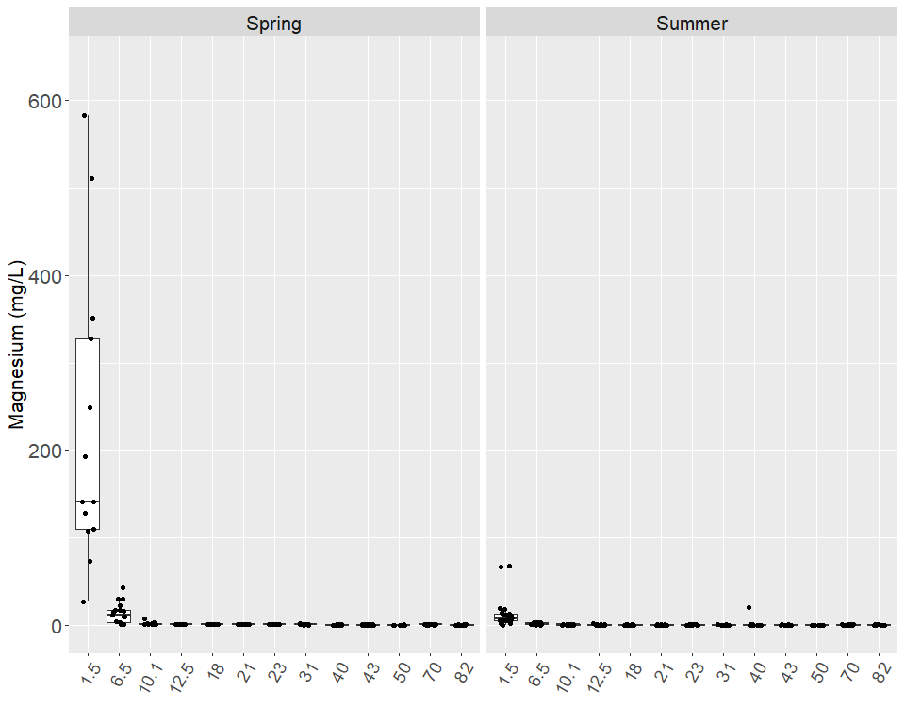

17. Nitrate
From the 2016 report:
Inorganic nitrogen is generally present in well-aerated, natural streams in the form of nitrate (Glass, 1999). Nitrate enters the hydrologic cycle as a result of precipitation, plant residue, natural minerals, fertilizer, and septic tanks (Glass, 2001). Neither the USEPA nor the ADEC have set a nitrate standard for chronically exposed freshwater aquatic life.
In the mainstem, the highest concentration of nitrate was 0.706 mg/L at Mile 70 during spring 2005, and in many instances, nitrate levels were below the MDL of 0.015 mg/L (Table 15). In the spring, the mainstem had a general downward trend from Kenai Lake to the estuary, excluding the higher medians at Mile 70 and Mile 1.5. The medians in the summer had a downward trend from Mile 82 through Mile 40, but then the medians hovered around 0.15 mg/L through the Lower Kenai River and dropped in the estuary. Overall, nitrate levels were slightly lower in the spring than in the summer for the mainstem (Figures 100 & 101).
The tributaries generally had lower levels of nitrate than the mainstem, with the exception of Russian River. The highest level of nitrate in the tributaries occurred at Russian River with a concentration of 1.11 mg/L during spring 2005, and the lowest levels occurred at many locations below the MDL of 0.015 mg/L (Table 41). Of the tributaries, Russian River had the highest medians in the summer and especially in the spring, which may explain the high median at Mile 70 in the mainstem. Juneau Creek in the spring and Slikok Creek in the summer had the next highest medians. Russian River had a higher median in the spring than the summer, while the other tributaries had too many values below the MDL and MRL to establish a clear seasonal trend (Figures 102 & 103).
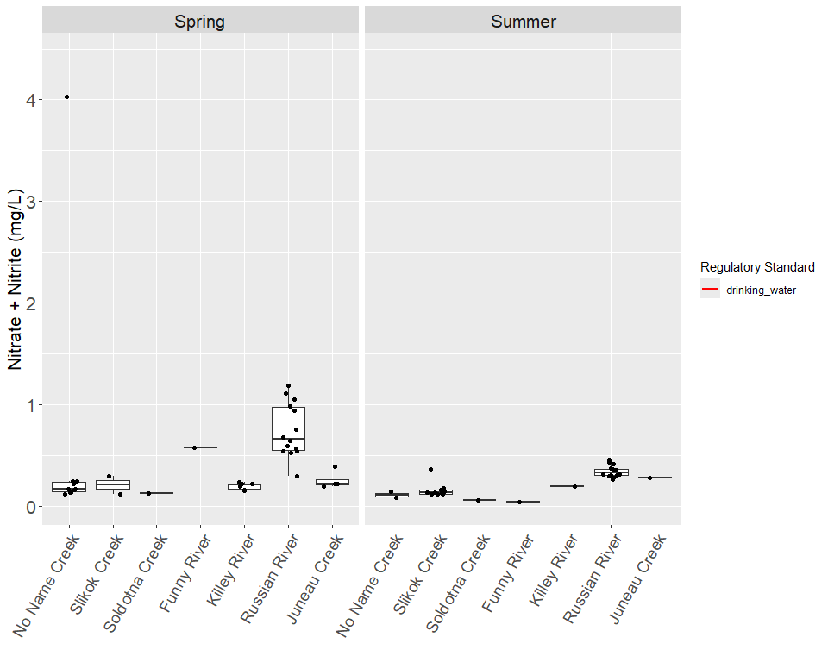
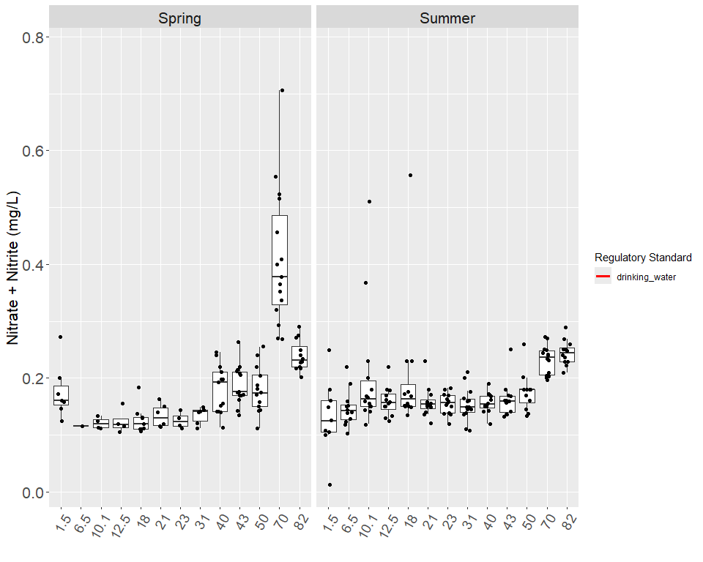
Regulatory thresholds for Nitrate + Nitrite (hardness-dependent ranges reflect observed hardness across all dataset years)
Standard Type | Value | Unit | Regulatory Authority
Drinking water (MCL) | 10 | mg/L | USEPA

18. Phosphorus
Plants and animals require the essential element phosphorus for growth, and most concentrations are not toxic to aquatic or human life (Glass, 1999). As a nutrient, phosphorus is significant to water quality because in high concentrations, it can lead to excessive algal growth and eutrophic conditions (Glass, 1999). The ADEC and the USEPA do not have a standard for phosphorus for chronic exposure to aquatic life in freshwater.
The highest level of phosphorus ever recorded occurred at Mile 1.5 in spring 2005 with a concentration of 4 mg/L, and the lowest levels occurred on many occasions below the MDL of 0.0020 mg/L in the spring and the summer (Table X). The estuary had significantly higher medians and variance than the rest of the mainstem in the summer and the spring. The lowest concentrations of phosphorus occurred between Mile 40 and Mile 82. In the mainstem, there was a general upward trend in phosphorus concentration from Kenai Lake to the estuary (Figures X & X).
In the tributaries, phosphorus ranged from 64 mg/L in Slikok Creek during May 2013 to below the MDL of 0.0020 mg/L at many locations in the spring and the summer (Table X) Beaver Creek had the highest median in the spring but dropped to the second highest in the summer, after the Killey River. Funny River had relatively high medians during both the spring and the summer. In contrast, Russian River displayed the lowest median in both the spring and the summer (Figures X & X).
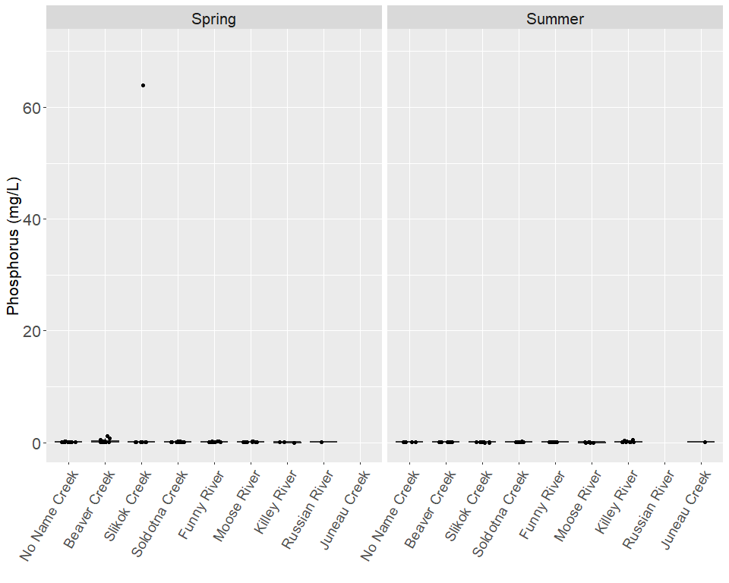
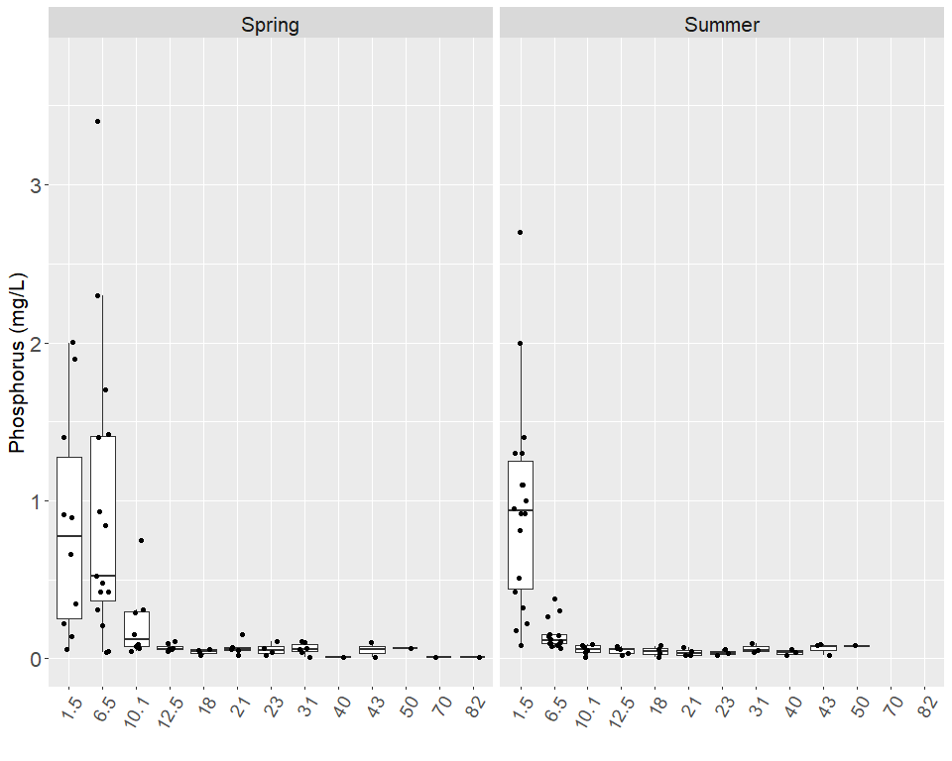

19. BTEX
From the 2016 report:
Benzene, toluene, ethylbenzene, m,p-xylene, and o-xylene are the aromatic hydrocarbons that are commonly referred to as BTEX. Volcanoes and forest fires are natural sources of benzene, and benzene is also a component in cigarette smoke, crude oil, and gasoline (ATSDR, 2005a). Benzene breaks down slowly in water and soil, but concentrations do not build up in plants and animals (ATSDR, 2005a). A natural part of crude oil, toluene is used to produce gasoline, paint, paint thinner, lacquer, and adhesives (ATSDR, 2001). Toluene can enter surface water due to petroleum or solvent spills and engine exhaust, but does not buildup to high concentrations in animals (ATSDR, 2001). Ethylbenzene is a colorless liquid found naturally in coal tar and petroleum, and is often used as a solvent and as a component in fuel, ink, insecticide, and paint (ATSDR, 1999). Xylene has three forms or isomers called meta-xylene, para-xylene, and ortho-xylene, which are reported in this study as m,p-xylene and o-xylene. As a natural part of petroleum and coal tar, xylene has many uses as a solvent, cleaner, paint thinner, and a small component of gasoline (ATSDR, 2005b). Once xylene enters surface water, it evaporates quickly into the air, but a small amount can concentrate in aquatic life (ATSDR, 2005b). The ADEC standard is 10 µg/L for total aromatic hydrocarbons in freshwater for the growth and propagation of fish, shellfish, other aquatic life, and wildlife (see Appendix 2) (ADEC, 2012). Additionally, the ADEC requires that surface waters do not have any floating oil, film, sheen, or discoloration due to hydrocarbons and that in shoreline or bottom sediments, there cannot be any concentration of petroleum hydrocarbons that cause deleterious effects to aquatic life (ADEC, 2012).
The highest level of BTEX in the mainstem occurred at Mile 1.5 at a level of 15.2 µg/L in summer 2002, and the lowest levels were reported as non-detect because they were below the MDLs and MRLs. No BTEX was reported in any of the spring samples, but high levels were detected in the lower river during the summer (Table 25). No median of BTEX exceeded the Alaska standard, but individual samples from Mile 1.5 and 6.5 exceeded the standard during the summer of 2000, 2001, 2002 and 2003. A clear upward trend is evident from Mile 23 to Mile 1.5, and Mile 40 and Mile 43 show BTEX medians above the next two downstream sites. No BTEX was ever detected at Mile 70 (Figures 114 &115).
In the tributaries, concentrations ranged from 6.65 µg/L in the Moose River in summer 2002 to non-detects reported in many instances. None of the tributaries had reported levels above the standard (Table 51). However, Beaver Creek, Soldotna Creek, the Moose River, the Killey River each had multiple instances of detection, and the Russian River reported one occasion of detection in summer 2008 (Figures 116 &117).
A trend analysis was conducted using the average and median values for data collected during the summer 2000-2013. The concentrations of BTEX throughout the entire Kenai River show higher levels of BTEX in the lower part of the Kenai River and very low concentrations in the headwaters (Figure 114 and Figure 115). The same analysis was done for each sampling station at the Kenai River; all but three stations show a decrease in BTEX concentration over time. Station at Mile 10.1 shows a decreasing trend until 2010. A Sampling event in 2012 starts an upward trend in the BTEX concentration (Figures 118-125).
All of the aromatic hydrocarbons of BTEX are typically associated with gasoline (Oasis Environmental, Inc., 2004). Litchfield and Kyle suggest that motorized boats could be the primary contamination source since peak times of outboard motor use coincided with peak concentrations of BTEX (1992). In 2003, the Kenai Watershed Forum determined that the majority of hydrocarbon contamination resulted from unburned refined gasoline product with outboard motors as the most likely source. In March 2008, the Alaska Department of Natural Resources Division of Parks and Recreation banned the use of two-stroke engines, with the exception of direct fuel injected (DFI) engines, within the Kenai River Special Management Area.
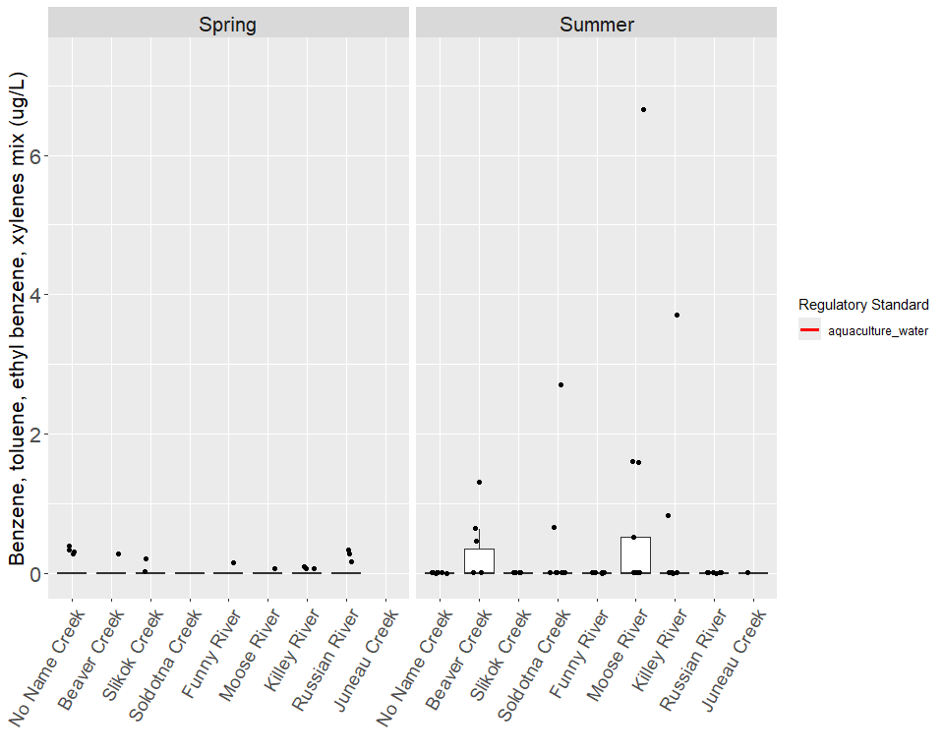
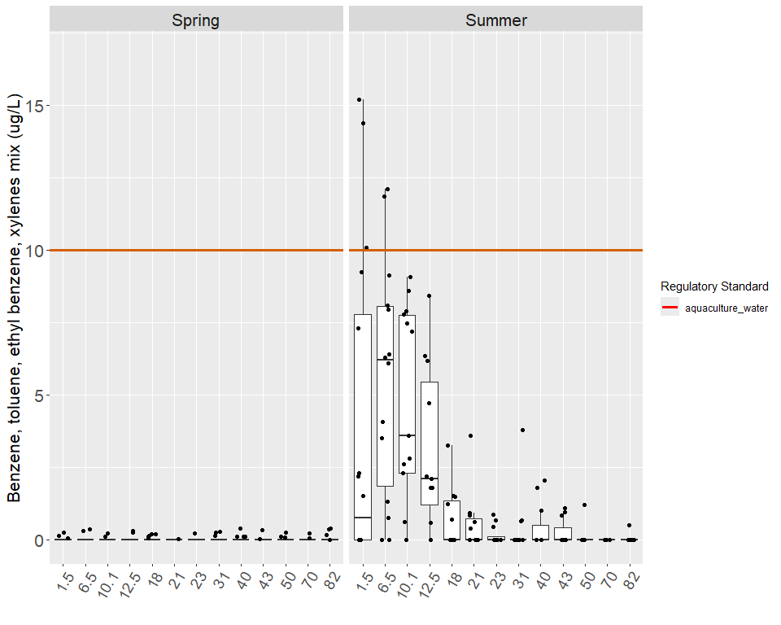
Regulatory thresholds for Benzene, toluene, ethyl benzene, xylenes mix (hardness-dependent ranges reflect observed hardness across all dataset years)
Standard Type | Value | Unit | Regulatory Authority
Aquaculture | 10 | µg/L | ADEC

20. Fecal Coliform Bacteria
The presence of fecal coliform bacteria in surface water indicates fecal contamination from warm-blooded animals, which is linked to disease-causing viruses and bacteria (Glass, 1999). Sources of fecal coliform bacteria include waste from septic systems, domestic animals, waterfowl, and other wildlife (Glass, 1999). The ADEC and USEPA standards for fecal coliform bacteria have two types of critera, a 30-day geometric mean and a no more than 10% of the samples can exceed a specified value criteira. The geometric mean criterian was not evaluated in this study because not enough samples were collected during any 30-day period. For reference, the ADEC fecal coliform drinking water standard states that in a 30-day period, the geometric mean of samples may not exceed 20 CFU/100ml and not more than 10% of the total samples may exceed 40 CFU/100ml (ADEC’s single sample limit). The ADEC fecal coliform secondary recreation standard states that in a 30-day period, the geometric mean of samples may not exceed 200 CFU/100ml and not more than 10% of the total samples may exceed 400 CFU/100ml (see Appendix X) (ADEC, 2002).
The highest level of fecal coliform recorded was 2980 CFU/100ml at Mile 6.5 during the summer 2002, however this sample may be unreliable because the duplicate sample was below the MDL of 1 CFU/100ml. The next highest recorded concentration in the mainstem was 580 CFU/100ml at Mile 6.5 during the summer of 2003, and the lowest levels were 0 CFU/100ml at several locations (Table 26). The highest median in the mainstem occurred at Mile 6.5 in the spring and at Mile 1.5 in the summer. The other medians along the mainstem were all below 10 CFU/100ml for the summer and the spring. The concentration of fecal coliform was generally higher in the summer than in the spring in the mainstem and the tributaries (Figures X - X).
In the tributaries, the concentration of fecal coliform ranged from a high of 520 CFU/100ml in Soldotna Creek during spring 2001 to 0 CFU/100ml at multiple sites (Table 52). During the spring, Beaver Creek had the highest median, and during the summer, No Name Creek had the highest median. In the summer, the median concentrations were relatively high in Slikok Creek and Beaver Creek, in addition to No Name Creek. Juneau Creek, Russian River, Killey River, and Moose River all had relatively low medians during the spring and the summer. In the summer, the tributaries had higher median concentrations of fecal coliform than the mainstem, but in the spring, the levels in the tributaries and the mainstem were more similar. (Figures X - X)
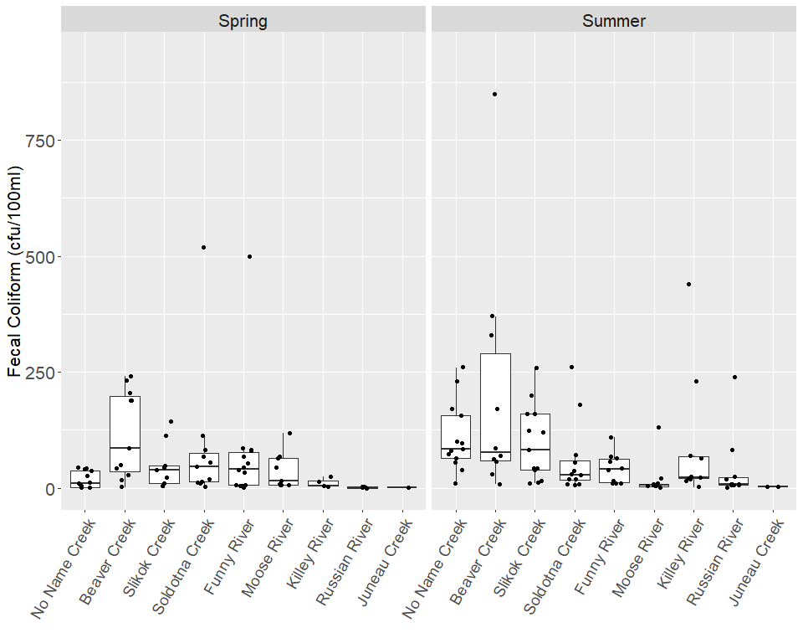
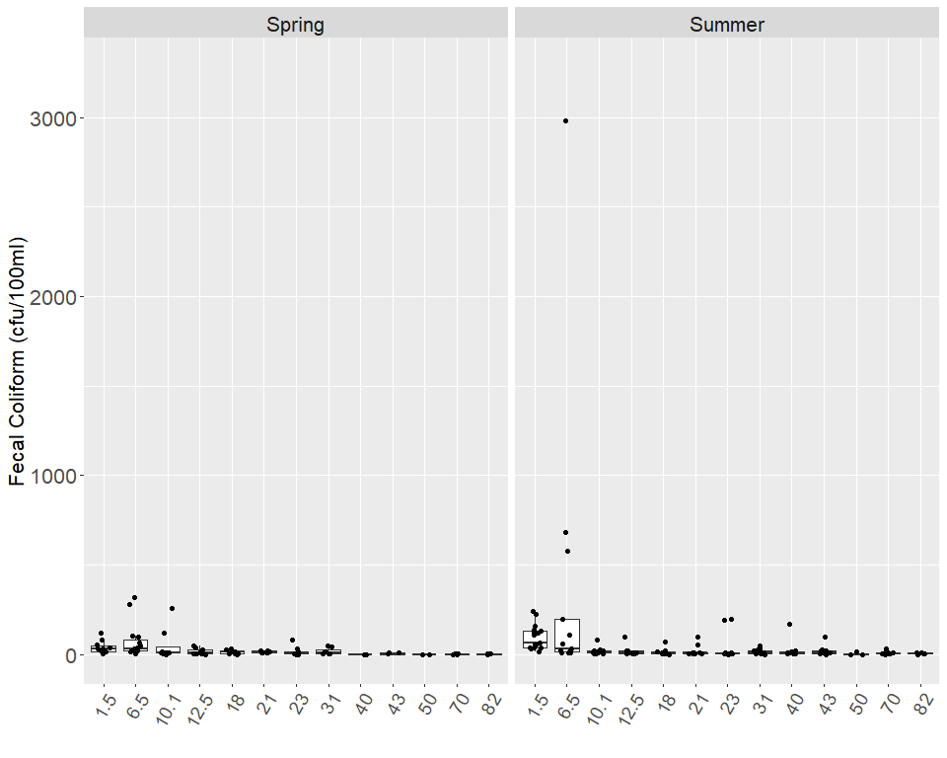

21. pH
The concentration of hydrogen-ion activity is represented by a pH measurement on a logarithmic scale ranging from 0 to 14 with acidic conditions closer to 0 and alkaline conditions closer to 14 (Glass, 1999). Values of pH ranging from 6.5 to 8.0 are typical in unpolluted river water, and these values can be affected by both natural and human processes (Glass, 1999). The ADEC standard for pH maintains that freshwater may not have a pH less than 6.5 or greater than 8.5 for the growth and propagation of fish, shellfish, other aquatic life and wildlife (see Appendix 2) (ADEC, 2012). Additionally, the standard stipulates that the pH may not vary more than 0.5 pH units from natural conditions and that in any water with a pH naturally outside the specified range, variation of pH must be toward the specified range (ADEC, 2012).
In the mainstem, the pH ranged from a high of 8.52 at Mile 50 in summer 2002 to a low of 6.16 at Mile 10.1 in summer of 2010 (Table 27). All the medians along the mainstem were between 7 and 8 for the spring and the summer, so they did not exceed the upper and lower limits. Individual samples exceeded the lower limit once at Mile 12.5 and Mile 43 in the spring and Mile 10.1 in the summer, and the upper limit was exceeded by a single sample at Mile 50 in the summer. The pH was generally lower in the spring in comparison to the summer in both the mainstem and the tributaries (Figures X & X).
The highest pH ever sampled was 9.03 at Moose River during summer 2002, and the lowest was 6.2 at No Name Creek in spring 2005 (Table 53). The medians of the tributaries did not exceed either the upper or lower pH limit. The lower limit was exceeded on one occasion each in No Name Creek, Beaver Creek, and Slikok Creek in the spring, and three samples from the Moose River exceeded the upper limit in the summer. The Moose River had the highest median pH in the summer, followed by the Russian River. From spring to the summer, the Killey River median remained near 7, while the other tributaries increased toward 7.5. Excluding the Moose River, the spring samples from the tributaries and the mainstem displayed greater variability than the summer samples (Figures X & X).
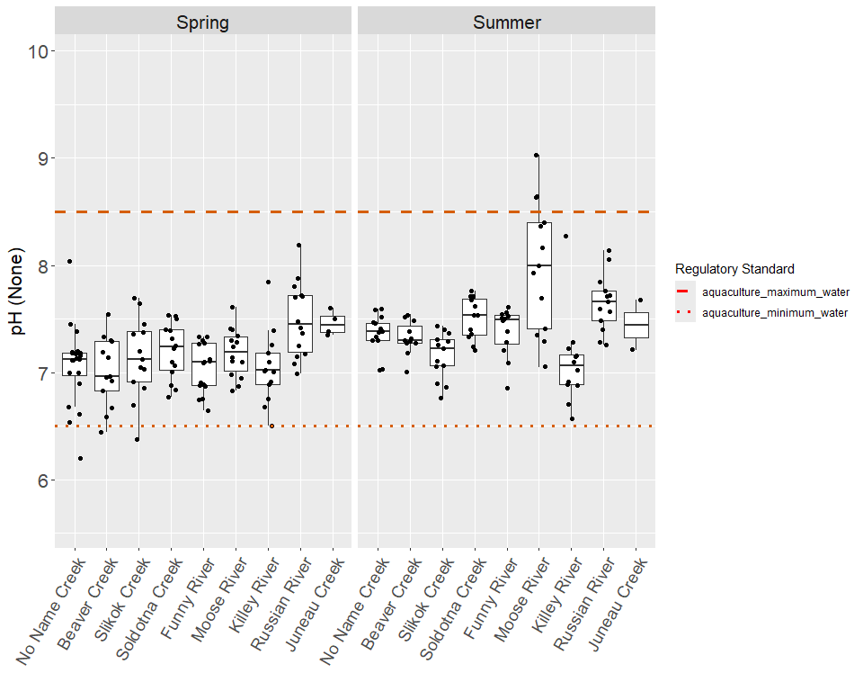
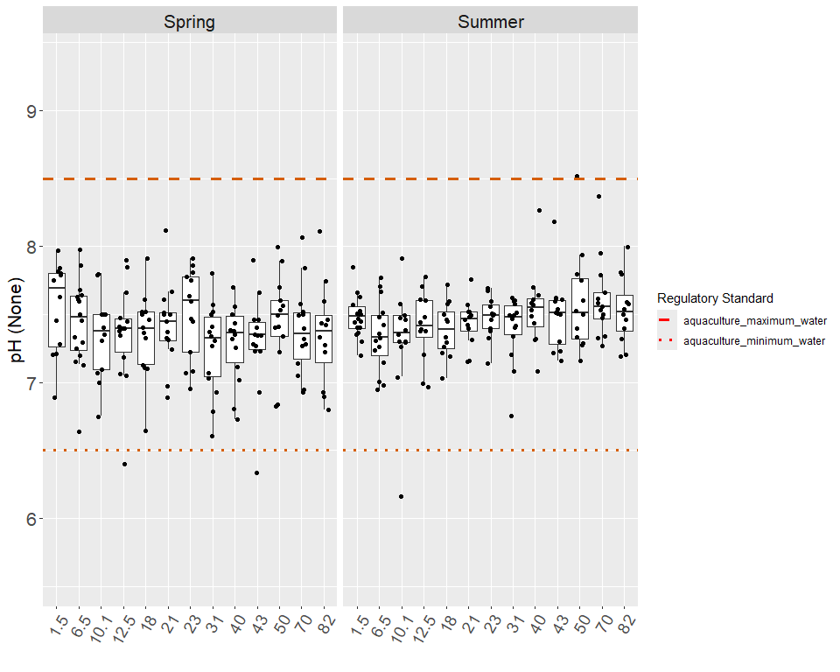
Regulatory thresholds for pH (hardness-dependent ranges reflect observed hardness across all dataset years)
Standard Type | Value | Unit | Regulatory Authority
Aquaculture (minimum pH) | 6.5 | — | ADEC
Aquaculture (maximum pH) | 8.5 | — | ADEC

22. Specific Conductance
The capacity of water to conduct electricity is measured by specific conductance, and the level of specific conductance also correlates with the concentration of calcium, dissolved solids, and the water’s hardness (Glass, 1999). There is not currently an ADEC or USEPA standard for specific conductance for aquatic life in freshwater.
The highest level of specific conductance in the mainstem was 29398 µS/cm, which was sampled at Mile 1.5 in spring 2011, and the lowest level was 37.7 µS/cm at Mile 50 in spring 2004 (Table X). Mile 1.5 had the greatest variance and the highest median in both the spring and the summer, followed by Mile 6.5 in the spring and Mile 70 in the summer. From Mile 10.1 to Mile 50, the specific conductivity medians only varied within a span of 15 µS/cm in both spring and summer, with the lowest median at Mile 43. Above Skilak Lake at Mile 70 and Mile 80, specific conductivity was higher relative to the rest of the mainstem, excluding the estuary. Specific conductivity was higher in the spring than in the summer throughout the mainstem, except at Mile 50 where specific conductance was higher during the summer (Figures X & X).
In the tributaries, specific conductance ranged from a high of 1088 µS/cm in No Name Creek during spring 2010 to the lowest level of 18 µS/cm in the Killey River during summer 2004 (Table X). The Killey River maintained the lowest median during the spring and the summer, while the highest median was in No Name Creek for both the spring and Soldotna Creek for the summer. The tributaries had higher levels of specific conductance in the summert, except for the Killey River, Russian River and Juneau Creek. In the summer, the tributaries generally had higher medians than the mainstem, but a corresponding trend was not apparent in the spring data (Figures X & X).
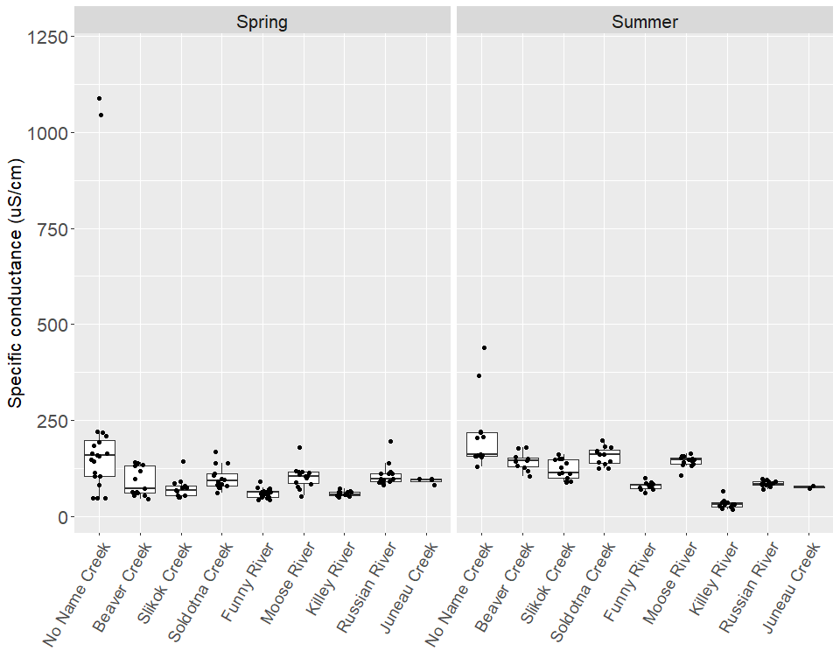
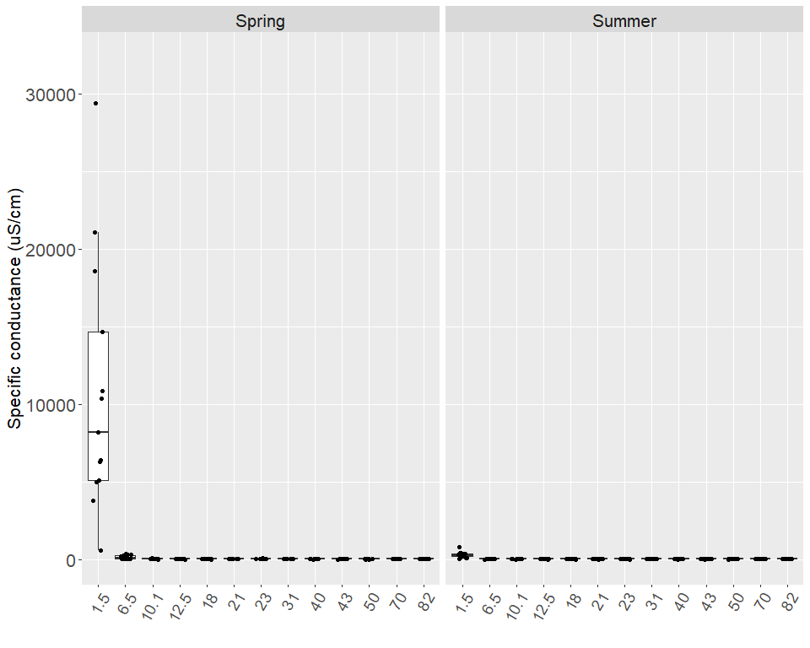

23. Total Suspended Solids
The concentration of total suspended solids is a way of measuring the amount of mineral and organic particles that are transported in the water column (Bash and others, 2001). Erosion increases the amount of suspended sediment in surface water and can be naturally caused by glaciers, fires, and floods (Glass, 1999). In the Cook Inlet Basin, glaciers are the main cause of erosion, but mining, logging, construction, and recreation can also contribute to elevated levels of suspended sediment (Glass, 1999). High concentrations of suspended sediment can be lethal to post-larval fish, and incubating eggs can suffer severe mortality rates because settled sediment prevents the exchange of oxygen (Glass, 1999). As such, the ADEC standard requires that fine sediment in the range of 0.1 mm to 4.0 mm cannot increase over 5% by weight higher than natural conditions in gravel beds used by anadromous or resident fish for spawning, and the sediment can never exceed a maximum of 30% by weight in freshwater for the growth and propagation of fish, shellfish, other aquatic life, and wildlife (see Appendix 2) (ADEC, 2012). More generally, the ADEC standard also states that the amount of deposited or suspended sediment cannot cause adverse effects on aquatic life, including their habitat and reproduction (ADEC, 2012).
The concentration of 2073 mg/L at Mile 6.5 during spring 2006 was the highest level of total suspended solids recorded in the mainstem, and the lowest concentration was less than the MDL of 0.48 mg/L during spring and summer sampling events (Table X). The estuary had much higher medians than the rest of the mainstem in both the summer and the spring. The medians were lowest in the spring and the summer in the Upper River from Mile 82 to Mile 50. Between Mile 50 and Mile 43, the concentration of total suspended solids increased, possibly due to the influence of the Killey River, which had higher levels of total suspended solids than the mainstem, especially in the summer. From Mile 43 to Mile 18, the medians in the spring and the summer for total suspended solids decreased relatively, and then there was an increase in the medians from Mile 12.5 to the estuary. During the spring, the concentrations in the estuary were significantly higher than in the summer, but this pattern was not as clear in the remainder of the mainstem (Figure X).
In the tributaries, the concentration of total suspended solids ranged from a high of 748 mg/L in Beaver Creek in spring 2009 to a low of less than the MDL of 0.48 mg/L (Table X). The Killey River had the highest median and largest variance by far in the summer. Funny River also had a relatively large degree of variance, but had a similar median to the other tributaries, excluding the Killey River in the summer. During the spring, Beaver Creek had the highest median and a relatively large degree of variance. Russian River had the lowest median of total suspended solids in the spring and Juneau Creek in the summer. Excluding Russian River and Killey River, the tributaries had higher medians during the spring rather than the summer. (Figures X)
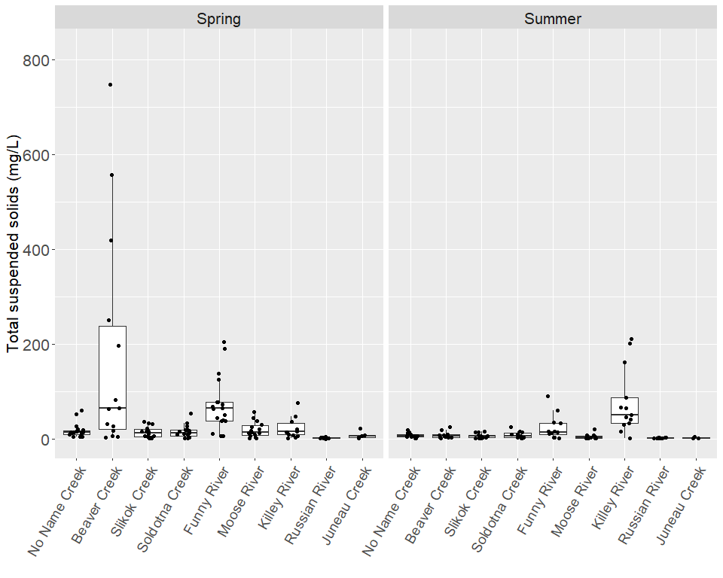
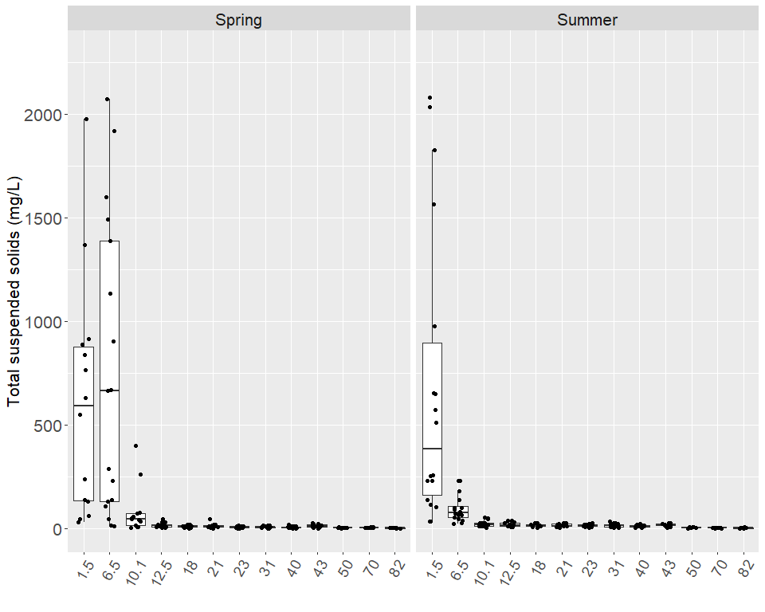

24. Turbidity
Turbidity measures the degree to which suspended and dissolved materials cause light to scatter instead of being transmitted in straight lines, and these materials consist of silt, clay, chemicals, microscopic organisms, and fine organic or inorganic matter (Bash and others, 2001). Turbidity varies naturally; higher turbidities are typically found in watersheds fed by glacial melt water, and turbidity generally increases from headwater tributaries to mainstems and estuaries (Bash and others, 2001). Even though salmonids can naturally live in turbid water systems, they do not always cope well with increases in suspended sediments, and these high levels in suspended sediments can cause fatalities, while lower levels can result in difficulty finding food, reduced growth, increased stress, and difficulty migrating (Bash and others, 2001). The ADEC standard states that turbidity may not exceed 25 NTU above natural conditions in freshwater or 5 NTU above natural conditions in lakes for the growth and propagation of fish, shellfish, other aquatic life, and wildlife (see Appendix X) (ADEC, 2012).
The highest level of turbidity occurred at Mile 6.5 in spring 2006 and was detected at 3200 NTU, and the lowest level in the mainstem was 1 NTU at Mile 70 in spring 2009 (Table 30). The highest medians and degree of variance for turbidity were in the estuary for both the spring and the summer, and the lowest median occurred at Mile 50. In the summer, from Mile 43 to Mile 1.5, the median level of turbidity generally increased. The spring medians in the estuary and Upper River were higher than the summer medians, but the rest of the mainstem had higher medians in the summer (Figure X).
In the tributaries, the highest level of turbidity was 336 NTU at Beaver Creek in spring 2010, and the lowest level was at Russian River with the level of 0.02 NTU from summer 2006 (Table X). During the summer, the Killey River had the highest median at 41 NTU, while the other tributaries all had medians less than 20 NTU. In the spring, Beaver Creek had the highest median, followed by No Name Creek and then Funny River. Russian River had the lowest turbidity median in both the summer and the spring. Killey River exhibited the largest seasonal difference in medians by increasing around 35 NTU from the spring to the summer. In contrast, Beaver Creek decreased approximately 13.3 NTU during the summer. The tributaries did not display a clear seasonal trend for increased or decreased turbidity (Figure X).
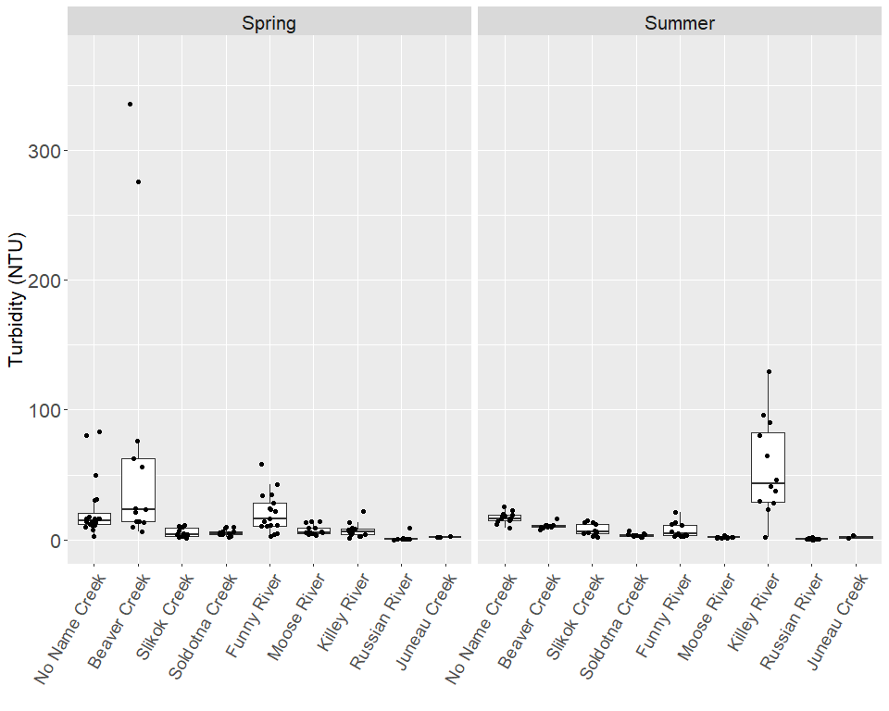
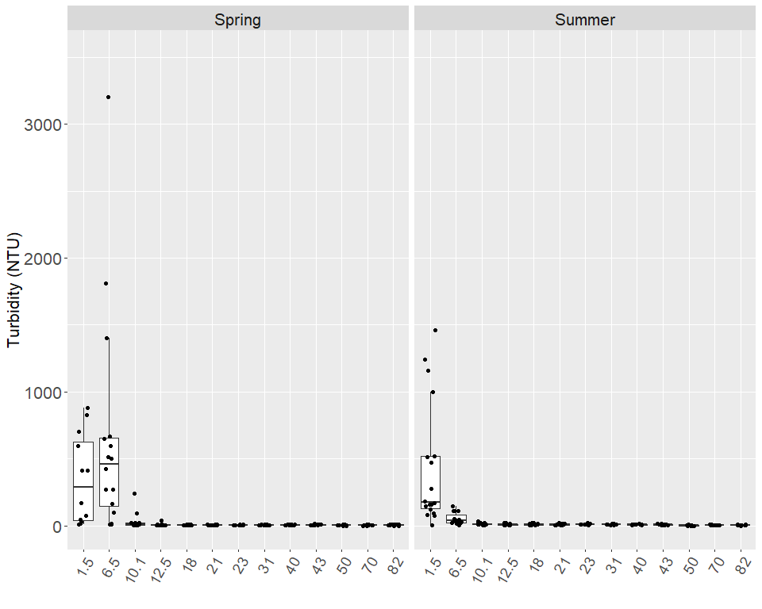

25. Temperature
The Kenai River is a complex mosaic of water temperature regimes, from glacially-influenced streams like Ptarmigan Creek (not monitored in this study) to mountainous but mostly glacier-free watersheds like the Russian River to lowland tributaries like Beaver Creek.
The technology used to monitor environmental water temperatures has progressed remarkably since this project initiated in the year 2000. Single-point instantaneous water temperature measurements, as described in the current QAPP, will continue to be an important aspect of this work. However, stream and lake temperatures overall are better understood as continuous time series. To this end, AKTEMP, an online repository specifically designed for water temperature data, is home to Kenai Watershed Forum’s water temperature monitoring efforts.
Single-point observations described here should be evaluated in context of these larger datasets where possible
(Writing in progress here 1/15/2025; old text below)
Low water temperatures between 0°C and 4°C can result in low growth rates for fish, but much higher water temperatures can encourage disease, competitors, predators, mortality, and an oxygen-deprived habitat (Kyle and Brabets, 2001). The ADEC has five temperature standards for the growth and propagation of fish, shellfish, other aquatic life, and wildlife in freshwater; the water temperature must remain below 20°C in all areas, below 15°C in rearing areas and migration routes, and below 13°C in egg and fry incubation and spawning areas (see Appendix X) (ADEC, 2012).
The highest temperature recorded on the mainstem occurred at Mile 1.5 in the summer of 2014 with a value of 17.02°C, and the lowest recorded temperature along the mainstem was –0.15°C at Mile 12.5 in spring 2002 (Table X). In the spring, two of the temperatures exceeded the standard for rearing areas and migration routes. There was a general upward trend from Mile 82 to Mile 1.5. It is important to notice that during the sampling event of the spring 2014, twelve out of thirteen sites exceeded the standard for egg and fry incubation and spawning areas. During the summer, the medians at Mile 1.5, Mile 6.5 and Mile 50 were very close to exceeding the standards for egg and fry incubation and spawning areas, and no medians exceeded the other standards. There was a general upward trend from Mile 82 to Mile 1.5, with an upward jump in the median at Mile 50, the outlet of Skilak Lake (Figure X).
In the tributaries, the highest temperature was 19°C in the Moose River during summer 2003, and the lowest temperature was –0.21°C in the Killey River during spring 2002 (Table X). In the spring, No Name Creek, Soldotna Creek and Russian River exceeded the standards for rearing areas and migration routes. Also, Slikok Creek, Funny River and Moose River exceeded the standard for egg and fry incubation and spawning areas. All tributaries had medians below 5°C, with the highest at Russian River and the lowest at Funny River. During the summer, the medians of Beaver Creek, Soldotna Creek, and Moose River exceeded the standards for egg and fry incubation and spawning areas, and the median at Moose River also exceeded the standards for rearing areas and migration routes. The coldest tributary in the summer was the Killey River, followed by Juneau Creek, Funny River and then Slikok Creek. The median water temperatures were higher in the summer than in the spring for all sampling locations in both the mainstem and the tributaries. For this analysis there were no values available for temperature during the sampling event of spring 2012 (Figure X).
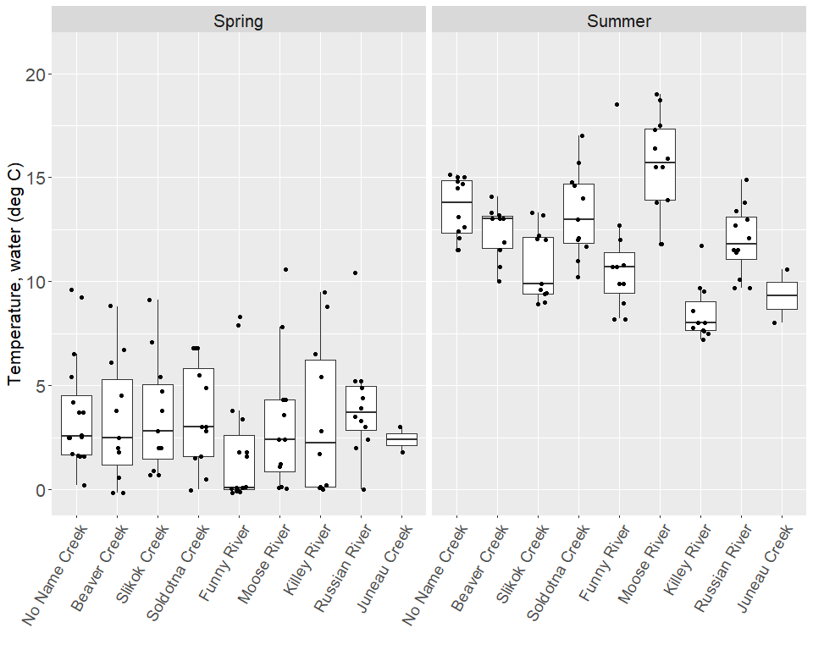
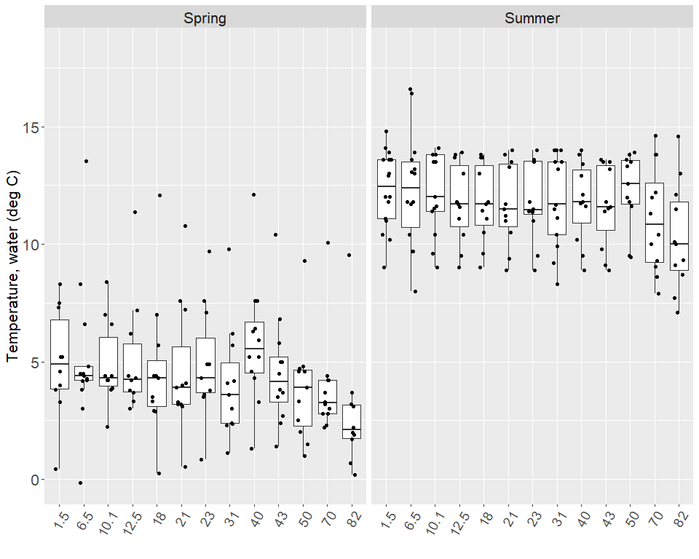

26. Summary
~2 page overall summary here.

References
ADEC. 2020. “18 AAC 70 Water Quality Standards.” https://dec.alaska.gov/media/1046/18-aac-70.pdf.
———. 2025. “18 AAC 70 Water Quality Standards.” https://dec.alaska.gov/media/1046/18-aac-70.pdf.
Apsens, S, and J Petitt. 2022. “Kenai River, Alaska Field Report 2021.”
Dorava, Joseph M, and Alexander M Milner. 2000. “Role of Lake Regulation on Glacier-Fed Rivers in Enhancing Salmon Productivity: The Cook Inlet Watershed, South-Central Alaska, USA.” Hydrol. Process. 14 (16-17): 3149–59. https://doi.org/10.1002/1099-1085(200011/12)14:16/17<3149::aid-hyp139>3.0.co;2-y.
EPA. 2011. “Nonpoint Source Program Success Story, Alaska: Upgrading Boat Motors Reduces Hydrocarbon Pollution.” https://19january2017snapshot.epa.gov/sites/production/files/2015-10/documents/ak_kenai.pdf.
Glass, RL. 1999. “Water-Quality Assessment of the Cook Inlet Basin, Alaska Summary of Data Through 1997.” https://doi.org/10.3133/wri994116.
Guerron Orejuela, Edgar. 2016. “Water Quality Assessment of the Kenai River Watershed from July 2000 to July 2014.” https://dec.alaska.gov/media/16756/kenai-river-baseline-monitoring-report-final-zncuappendix.pdf.
Kenai Watershed Forum. 2012. “Quality Assurance Project Plan, Kenai Watershed Forum, Kenai River Watershed Monitoring Program.”
———. 2019. “Quality Assurance Project Plan, Kenai Watershed Forum, Kenai River Watershed Monitoring Program, V2.0.”
———. 2023. “Kenai River Water Quality Monitoring Quality Assurance Project Plan, Multi-Agency Baseline (QAPP) V3.0.” Soldotna, AK. https://www.kenaiwatershed.org/wp-content/uploads/2023/05/KenaiWatershedForum_QAPP_v3_2023.pdf.
McCard, Jennifer J. 2007. “Water Quality Assessment of the Kenai River Watershed from July 2000 to July 2006.”
Reeves, Mari Kathryn, Margaret Perdue, Lee Ann Munk, and Birgit Hagedorn. 2018. “Predicting Risk of Trace Element Pollution from Municipal Roads Using Site-Specific Soil Samples and Remotely Sensed Data.” Sci. Total Environ. 630 (July): 578–86. https://doi.org/10.1016/j.scitotenv.2018.02.171.
Schoen, Erik R, Mark S Wipfli, E Jamie Trammell, Daniel J Rinella, Angelica L Floyd, Jess Grunblatt, Molly D McCarthy, et al. 2017. “Future of Pacific Salmon in the Face of Environmental Change: Lessons from One of the World’s Remaining Productive Salmon Regions.” Fisheries 42 (10): 538–53. https://doi.org/10.1080/03632415.2017.1374251.
Wickham, Hadley, and Garrett Grolemund. 2017. R for Data Science. O’Reilly. https://r4ds.had.co.nz/index.html.
Willette, T. M., J. M. Edmundson, and R. D. DeCino. 2004. “Kenai River Estuary Baseline Fisheries Assessment.” Anchorage, Alaska.

Appendix A — Appendix: Data Review and Upload

A.1 Introduction
Prior to publishing analysis and interpretation of water quality data, we will ensure that all data that meets QA/QC standards outlined in the current project Quality Assurance Project Plan (QAPP) and is accessible in the appropriate public repository.
Water quality data from this project is ultimately destined for the Environmental Protection Agency’s Water Quality Exchange (EPA WQX).
The Quality Assurance Project Plan (QAPP) for this project describes data management details and responsible parties for each step of the data pipeline from observation to repository. The 2021 data preparation and review process is published here as an appendix as an example of the process applied annually to each year’s data.
Year 2021 QA/QC is included here as an example. Other project years QA/QC may be accessed at https://kenai-watershed-forum.github.io/kenai-river-wqx-qaqc/.

A.1.1 Year 2021 Water Quality Data
In this appendix we will collate 2021 laboratory data from several sources into a single spreadsheet document with a consistent format. The desired end format is a spreadsheet template provided by the EPA Water Quality Exchange. These template files are available to download from the EPA at https://www.epa.gov/waterdata/water-quality-exchange-web-template-files.
Once the data is collated, it will be evaluated according to a Quality Assurance Checklist (template example provided by the Alaska Department of Environmental Conservation Soldotna office). Field observations that do not meet the quality assurance standards described in the evaluation checklist will be flagged before being uploaded to the EPA WQX.
Data that has been uploaded to the EPA WQX is evaluated biannually by the Alaska Department of Environmental Conservation (ADEC) in their Integrated Water Quality Monitoring and Assessment Report. The integrated report evaluates available water quality data from the previous five years against Alaska water quality standards and regulations (ADEC 2020).

A.1.1.1 2021 Water Quality Data WQX Formatting
The code scripts in this document assemble water quality data from the three analytical laboratories that partnered with Kenai Watershed Forum for this project in 2021:
- SGS Laboratories (Anchorage, AK)
- Soldotna Wastewater Treatment Plant (Soldotna, AK)
- Taurianen Engineering and Testing (Soldotna, AK)

A.1.1.1.1 2021 Metals/Nutrients Lab Results (SGS Labs)
*Note: the chain of custody documents for SGS Laboratories are integrated into the above downloadable PDF files.

A.1.1.1.2 2021 Fecal Coliform Lab Results (Soldotna Wastewater Treatment Plant (SWWTP)/Taurianen Engineering)

A.1.1.1.3 2021 Total Suspended Solids Lab Results (Soldotna Wastewater Treatment Plant (SWWTP))

A.1.2 2021 Provisional Results, Prior to QA/QC Review
Results last updated 2026-03-28
The above data sources have been collated in to a single .csv file (available for download) into a format compatible with the EPA Water Quality Exchange. These data have not yet been evaluated against QA/QC standards following guidance in the current project Quality Assurance Project Plan.

A.1.3 2021 Data QA/QC Evaluation
Prior to upload to the EPA WQX, all water quality data must be checked against a series of standard questions in order to evaluate how quality assurance / quality check (QA/QC) requirements are met. The draft Data Evaluation Checklist Template (available for download below) outlines these questions:

A.1.3.1 Pre-Database

A.1.3.1.1 Overall Project Success
Note: the sequence of questions is structured such that data will be gradually flagged at each step based on the criteria described.
1.) Were the appropriate analytical methods used for all parameters?
Yes. Analytical methods from the approved 2020 QAPP were employed.

2.) Were there any deviations from the sampling plan?
All sites were visited as planned on 5/11/2021 and 7/27/2021. Most intrinsic water quality parameters measured with instruments (pH, dissolved oxygen, conductivity, turbidity) were not measured, which is a deviation of from the QAPP.

3.) Were field duplicates, blanks, and/or other QC samples collected as planned?

To see a table comparing planned vs actual results for 2021, download and view the csv file linked above.
From the above table we can see that there are deviations between planned results and actual results available. These reasons for the deviations are known and are attributable to two causes:
Cause 1: The Spring 2021 Chain of Custody (COC) from KWF to SGS was completed erroneously. The COC specified for EPA Method 200.8 analyses (dissolved metals) to be complete for all sites (when they should have stopped upstream of Morgan’s Landing RM31), and it also specified for EPA Method 200.7 analyses (total metals) to stop upstream of Morgan’s Landing (when they should have been performed for all sites in the project).
As a result, for Spring 2021 total metals data will be unavailable for sites upstream of the Morgan’s Landing RM31 site.
Cause 2: For Summer 2021, the SGS laboratory performed the EPA Method 200.8 analyses (dissolved metals) for all 27 analytes available for the method; instead of just the smaller subset of analytes as requested. (E.g., KWF received extra data for free. In this case., there are no consequences of deviating from the planned analyses).

4.) Do the laboratory reports provide results for all sites and parameters?
The laboratory reports provide results for all sites, and for all parameters, with the exceptions outlined above in question #3.

5.) Is a copy of the Chain of Custody included with the laboratory reports?
We worked with three separate laboratories in 2021:
- SGS Laboratories, Anchorage, AK
  - Chain of Custody documents are included within the PDF laboratory reports linked above earlier in this appendix.
- Soldotna Wastewater Treatment Plant, Soldotna, AK
  - Chain of Custody documents are on file with Kenai Watershed Forum for fecal coliform and total suspended solids for 5/11/2021, and for total suspended solids on 7/27/2021.
- Tauriainen Engineering & Testing, Soldotna, AK
  - An individual document for each sample reports the time and date of delivery and analysis for each sample. These documents are included with the PDF laboratory reports linked above earlier in this appendix.

6.) Do the laboratory reports match the Chain of Custody and requested methods throughout?
The laboratory reports match the Chain of Custody and requested methods, with the one exception discussed in question #3.
For summer 2021, the SGS laboratory performed the EPA Method 200.8 analyses for all 27 analytes available for the method; instead of just the smaller subset of analytes as requested. (E.g., KWF received extra data for free. In this case., there are no consequences of deviating from the planned analyses).

7.) Are the number of samples on the laboratory reports the same as on the Chain of Custody?
The quantity of sample bottles sent to the laboratories matches the number of analyzed samples for samples collected and delivered on 5/11/2021 and 7/27/2021.

8.) Was all supporting info provided in the laboratory report, such as reporting limits for all analyses and definitions?
We worked with three separate laboratories in 2021:
- SGS Laboratories, Anchorage, AK
  - SGS provided data as PDFs which included reporting limits, as well as in the form of an Electronic Data Deliverable where this information is also included in column format.
- Soldotna Wastewater Treatment Plant (SWWTP), Soldotna, AK
  - SWWTP provided data in the form of .xls files. Reporting limits are described in this project’s current Quality Assurance Action Plan.
- Tauriainen Engineering & Testing, Soldotna, AK
  - Tauriainen provided data in the form of PDF documents. Reporting limits are described in this project’s current Quality Assurance Action Plan.

9.) Are site names, dates, and times correct and as expected?
- Yes, after post-season correction documented in this report. Notes: In 2021 Kenai Watershed Forum used pre-printed waterproof labels on all sample bottles, reducing opportunity for field and lab transcription errors. Remaining site name transcription errors from laboratories were corrected in post-season data review, using scripted code that did not modify the original report.

10.) Were there any issues with instrument calibration?
- Instruments to measure intrinsic water quality parameters (sondes; to measure pH, dissolved oxygen, conductivity, turbidity) were not employed in 2021.
- Teams did use hand-held probes to record water temperature on-site. Prior to field use, the hand-held probes were verified as measuring within the accuracy level defined in the QAPP using an ice bath in the Kenai Watershed Forum laboratory.

11.) Did the instruments perform as expected?
- The hand-held water temperature probes performed as expected in 2021.

12.) Was instrument calibration performed according to the QAPP and instrument recommendations?
- Water temperature is a parameter that is “verified” rather than calibrated. The hand-held water temperature probes were verified as measuring within the accuracy level defined in the QAPP using an ice bath in the laboratory, according to instrument recommendations.

13.) Was instrument verification during the field season performed according to the QAPP and instrument recommendations?
- The hand-held water temperature probes were verified as measuring within the accuracy level define in the QAPP using an ice bath in the laboratory, according to instrument recommendations.

14.) Were instrument calibration verification logs or records kept?
- Yes. These records are held at Kenai Watershed Forum, 44129 Sterling Hwy, Soldotna, AK.

15.) Do the instrument data files site IDs, time stamps and file names match?
- Instrument files were not employed in 2021. Measurements from hand held probes were recorded on waterproof paper field forms.

16.) Is any insitu field data rejected and why?
- No insitu data is rejected from 5/11/2021 or 7/27/2021.

17.) Were preservation, hold time and temperature requirements met?
- Yes. Summer and Spring 2021 holding time requirements were met for all samples. See downloadable files below. Laboratory result documents indicated no compromises of preservation and temperature requirements.

18.) Are dissolved metal quantities less than total metals quantities?
- Dissolved metals results are not consistently less than total metals results, as would be logically anticipated (see post from Flowlink Environmental website for description and rationale):
  - “Dissolved metal concentration is determined by filtering a water sample through 0.45 uM filter. Water that passes through the filter is analyzed for metals and the result is reported as dissolved metal concentration. Total metal concentration is determined by analyzing the unfiltered sample.
  - “Total metal concentration = Dissolved metal concentration + Particulate (insoluble) metal concentration.”
  - In 2021, there are results available for both dissolved and total metals for three elements: Ca, Fe, and Mg; for sites at and downstream of RM 31.
  - Dissolved metals results are available for 7/27/2021 (summer) only, and not for 5/11/2021 (spring); see question #3 in this sequence.
- Results:
  - Calcium: all available observations show dissolved metals > total metals
  - Iron: all available observations show dissolved metals < total metals
  - Magnesium: nearly all available observations show dissolved metals < total metals, with the exception of two sites near the Kenai River mouth (RM 0 NNC and RM 1.5). At both sites the difference is small and may be within measurement uncertainty.

As of the time of this writing, it is unclear why dissolved metals values exceed total metals values for calcium at all measured sites, and for magnesium at two sites near the river mouth (RM 0 NNC and RM 1.5). Iron behaves as expected (total > dissolved) at all measured sites. This discrepancy for calcium and magnesium warrants follow-up in future sampling years.

19.) Are the duplicate sample(s) RPD (Relative Percent Difference) within range described in QAPP?
In 2021, field duplicate samples were collected at two sites on both 5/11/2021 and 7/27/2021:
- No Name Creek (Tributary, RM0)
- Funny River (Tributary, RM30)
Following the example in the Alaska Department of Environmental Conservation 2021 Kenai River Metals Field Report (Apsens and Petitt 2022): “… a set of paired samples was evaluated for RPD only if:
- a.) one or both of the samples were above the Limit of Quantitation (LOQ); AND if
- b.) one or both of the samples were at least two times the LOQ.”
A csv file of Relative Percent Difference values organized by site, date, and parameter may be downloaded below:

From the above downloadable table, we can see that a limited subset of paired values from field duplicates are eligible to be used for RPD calculations for 2021. Pairs of measurements must meet LOQ criteria described above (“a” and “b”) in order to be used. For 2021 data, of 69 paired field duplicate observations, 24 of them meet these criteria and thus may be used for RPD calculations.
RPD values range from 0 % to 165.22 %.
In the 2020 Quality Assurance Action Plan, Relative Percent Difference values for most parameters are set at 20%, with the exception of “Phosphorus, total” and “Nitrates (NO2+NO3)” at 25%, and “Suspended solids, total” at 5%.
Using the available RPD values against the above criteria, four paired observations exceed project precision goals in 2021. Three of these four observations are for fecal coliform, and one is for total phosphorus.
Most other parameters have at least one available RPD value that is within project precision goals defined in the QAPP.
The parameters that do not have at least one RPD calculation available, due to the LOQ constraints described above, are the following:
- Arsenic
- Cadmium
- Chromium
- Copper
- Lead
- Zinc
Other notes
In 2021 the full suite of dissolved metals was run for method 200.8 on samples from 7/27/2021. However we intend to only submit data for parameters that had a pre-defined QA plan as outlined in the QAPP, which is the case for the following dissolved six metals: Mg, As, Cd, Cr, Cu, Pb, and Zn.
Summary of Discussion on RPD (Relative Percent Difference) Values for 2021
We attempted to calculate RPD values for all parameters collected in 2021 at two field sites on two dates. For each pair of duplicate observations, one of the following descriptions apply:
- It was possible to calculate RPD values because:
  - a.) one or both of the samples were above the LOQ; AND one or both of the samples were at least two times the LOQ
    - Project data for this parameter will be submitted unflagged to EPA WQX if RPD values meet project goals outlined in the QAPP
- It was not possible to calculate RPD values because:
  - a.) one or both of the samples were not above the LOQ; OR one or both of the samples were not at least two times the LOQ
    - Project data for this parameter will be submitted unflagged to EPA WQX if both paired values are non-detect
KWF’s approach to flagging when RPD cannot be calculated follows the example of the Alaska Department of Environmental Conservation (ADEC) 2021 Kenai River Metals Field Report (Apsens and Petitt, 2021): when duplicate pairs cannot be evaluated for RPD because concentrations are at or below the LOQ, results are retained as accepted non-detect or estimated values rather than flagged. A below-LOQ result is not a precision failure — it reflects actual environmental conditions. Non-detect status is already documented in the Result Detection Condition column (U = not detected; J = detected below LOQ, treated as an estimate). KWF communicated with the Alaska Department of Environmental Conservation on August 22, 2023 via an inquiry on this topic. The memo includes a visual flow chart of the logic for when data is flagged, and is available for download below.

Final determinations on flagging / not flagging 2021 data submitted to the EPA WQX
All 2021 field results will be submitted unflagged to the EPA WQX unless discussed below.
- Fecal Coliform
  - Given that 3 out of 4 RPD values for fecal coliform values are >60%, field data values for the 2021 dataset may vary from actual environmental conditions. The 2020 KWF QAPP does not specify an RPD value for fecal coliform, it only specifies control checks for sterility and temperature. We used EPA Method 9222D (drinking water) for fecal coliform analysis methods, which does not specify an RPD value. However EPA general recommendations for pathogens in sewage sludge recommends and RPD of 20% (link).
  - Given the above considerations, KWF will submit 2021 fecal coliform data to the EPA WQX as “flagged”. Fecal coliform data will be evaluated in this report and assessed against state standards, but given the high RPD values among duplicate samples, 2021 data will likely not be considered in the context of potential regulatory exceedences.
  - A comparison of fecal coliform RPD values across years (2014–2022) and against results from the 2016 comprehensive report is recommended as a future step.
- Selected Dissolved Metals (As, Cd, Cr, Cu, Pb, Zn)
  - RPD calculations could not be performed for these parameters because concentrations at both the primary and duplicate sample locations were at or below the LOQ. Following the ADEC 2021 approach described above, these results are submitted to EPA WQX as Accepted, with non-detect or estimated status clearly documented in the Result Detection Condition and Result Qualifier columns. This approach recognizes that a below-LOQ result is not a precision failure.
  - Note: beginning in Summer 2022, KWF initiated a series of changes to the QAPP that will better facilitate QA/QC decisions regarding dissolved metals results in future years. These changes include use of a dissolved metals field blank and changing from field filtration to lab filtration as standard practice, both of which will improve the ability to detect contamination and calculate RPD for dissolved metals.

20.) Were there any laboratory discrepancies, errors, data qualifiers, or QC failures (review laboratory duplicates, matrix spikes and blanks)?
Laboratory discrepancies and QC failures from the SGS lab are described on page 2 of the spring and summer PDF document reports, which are available for download below.

The following discrepancies were identified in the results from SGS laboratories:
Matrix Spike Recoveries
A total of 6 matrix spike or matrix spike duplicate samples are outside of QC criteria. The limit of recovery range for the analyte “Total Nitrate/Nitrite-N” is 90% - 110%. For these matrix spike measurements outside of the QC criteria, recovery levels range from 112% - 118%. The subset of sample values that exceed threshold may be downloaded as a table below:

No additional laboratory QA/QC anomalies for any other parameters were noted by any laboratories contracted in 2021. Additional details are available upon request at hydrology@kenaiwatershed.org
As of 2026-03-28, “Total Nitrate/Nitrite-N” values will be flagged for the spring 2021 dataset. (Spring only and not summer because no matrix spike recovery exedences were observed from the summer 2021 lab results). The matrix spike recovery exceedances indicate that reported lab values may be 2% - 7% above actual field values. At a later date we will evaluate these results in the context of year 2000 - present data to help evaluate the relevancy of this flag.

21.) Is any laboratory data rejected and why?
No additional 2021 laboratory data currently indicates a need for being flagged or rejected.

22.) During the field season, review raw data files (EDDs [Electronic Data Deliverables], instrument records) as they are received. Document changes and corrections to methods as needed.
In 2021, KWF initiated as standard practice the receipt of machine-readable EDD files from contracted laboratories, in addition to PDF results. The EDD files are being reviewed as part of this QA/QC process, which was initiated in Winter 2022.

23.) Is the dataset complete and did you receive the expected number of results?
From the discussion and results in question #3, deviations are evident between planned and actual results reported. The reasons for the deviations are known and are attributable to the two factors discussed in question #3, and thus not concerning to project integrity.

24.) Was the data collected representative of environmental conditions?.
The data collected in this project is representative of seasonal hydrological conditions on two fieldwork days in 2021. Conditions vary instantaneously thus this dataset serves to provide representative longitudinal snapshots of the watershed across space on the two dates.
Flagged data indicates that lab results may not be representative of environmental conditions, and thus may require additional interpretation or exclusion from analysis.

25.) Does project meet Completeness Measure A criteria?
From the QAPP, Completeness Measure A: “the primary number of samples collected divided by the usable number of samples submitted to ADEC, with a goal of 85% completeness.” (Note that as of 2023 results are now submitted directly to EPA rather than DEC, per request of DEC).
(Note: metals parameters not specified in the QAPP are excluded from these analyses. In 2021, SGS laboratories provided dissolved metals results for parameters beyond what was originally requested.)
We calculated Completeness Measure A at the following project scales:
- For individual parameters
- For individual sites
- As a project whole

Discussion on “Completeness Measure A” Results
Based on the data flagging decisions discussed in the previous questions, the 2021 dataset did not achieve all Completeness Measure A goals.
When completeness results were summarized by parameter, all dissolved metals had a value of 0% for Completeness Measure A since the decision was made to flag these as a result of an inability to calculate Relative Percent Difference values.
When completeness results were summarised by Site, Completeness Measure A values ranged from 44.4% - 71.4%, depending on the site’s sampling plan.
When completeness results are summarized for the overall 2021 dataset, Completeness Measure A is calculated at 50.1%; indicating that 49.9% of the overall result values were flagged.

26.) Does project meet Completeness Measure B criteria?
From the QAPP, Completeness Measure B: “the planned number of samples divided by the useable samples (submitted to ADEC) with a goal of 60%.”
For these calculations, we will consider “usable” as “unflagged,” and will calculate at the following scales:
- For individual parameters (analysis methods)
- For individual sites
- As a project whole
Discussion on “Completeness Measure B” Results
Work in progress — results to be interpreted following review of output files above.

27.) Was the QA officer consulted for any data concerns?
Note: the 2012 and 2019 approved Quality Assurance Action Plan (QAPP) documents list Alaska Dept of Environmental Conservation Staff as the project’s QA officer (Kenai Watershed Forum 2012, 2019), whereas the 2023 approved QAPP lists Kenai Watershed Forum staff as the project QA officer (Kenai Watershed Forum 2023).
Kenai Watershed Forum consulted regularly with staff from the Alaska Department of Environmental Conservation and EPA Region 10 Office in order to prepare 2021 field data and confirm field methods and data QA/QC procedures.

28.) Are the correct monitoring locations associated with the project? Are latitude and longitude filled out in a consistent format?
We used the leaflet package to generate a map of unique sites from the 2021 dataset:
2021 monitoring locations
monitoring_location_id | activity_latitude | activity_longitude
KR RM 0 NNC | 60.55089 | -151.2684
KR RM 1.5 | 60.54368 | -151.2229
KR RM 10.1 | 60.53928 | -151.1423
KR RM 10 BC | 60.54803 | -151.1432
KR RM 12.5 | 60.53374 | -151.0993
KR RM 18 | 60.50200 | -151.1070
KR RM 19 SC | 60.48232 | -151.1271
KR RM 21 | 60.47663 | -151.0821
KR RM 22 SOC | 60.48336 | -151.0577
KR RM 23 | 60.48034 | -151.0308
KR RM 30 FR | 60.48996 | -150.8610
KR RM 31 | 60.49828 | -150.8631
KR RM 36 MR | 60.53687 | -150.7547
KR RM 40 | 60.51544 | -150.7021
KR RM 43 | 60.48984 | -150.6369
KR RM 44 KI | 60.48152 | -150.6325
KR RM 50 | 60.46752 | -150.5078
KR RM 6.5 | 60.54081 | -151.1828
KR RM 70 | 60.48139 | -150.1150
KR RM 74 RR | 60.48462 | -149.9940
KR RM 79.5 JC | 60.48900 | -149.8770
KR RM 82 | 60.49201 | -149.8108
In the above map we can see that coordinates for the 2021 field sites correspond to the locations listed in the Quality Assurance Project Plan, thus they are filled out in a consistent format.

29.) Are the QAPP and other supporting documents attached?
The QAPP will be included and attached in the data submission to the EPA WQX. Find the current approved QAPP posted on Kenai Watershed Forum’s website at https://www.kenaiwatershed.org/news-media/qapp-revisions-completed-2023/.

30.) Is all project metadata correct?
Answer TBD. More detail applied here once upload is complete.

31.) Is the organization ID correct?
Kenai Watershed Forum’s Organization ID in the EPA Water Quality Exchange is “Kenai_WQX.” This value is manually confirmed during the upload process.

32.) Are the time zones consistent and correct (AKDT in summer)?
All times zones are listed as AKDT.

33.) Are all media types included? Media types appropriate to Characteristic?
“Water” is the only media type considered in this project. All “Characteristics” (parameters) are measured from water samples or in-situ water conditions.

34.) Check Sample Collection, Preparation and Preservation Methods, Thermal Preservative, Equipment ID, Activity Media. Is supporting information included and correct??
[1] "Water Bottle"
“Sample collection method”: all sample values have “Equipment ID” listed as “Water Bottle.”
“Preparation”:this information corresponds to the “result sample fraction” column
“Preservation Methods”: this information corresponds to the “preservative” and “thermal preservative” columns.

35.) Are all expected activity types present and are QC samples correctly identified?
[1] "Field Msr/Obs"
[2] "Quality Control Field Replicate Msr/Obs"
[3] "Quality Control Sample-Trip Blank"

The activity types present are listed above. All three types were planned and anticipated. QC samples are described earlier in Question #3.

36.) Is the Activity media subdivision filled in (if relevant)?
[1] "Surface Water"
All “Activity Media Subdivision” names are listed as “Surface Water.”

37.) For Water activity media, is the relative depth filled in?
Yes, “activity depth height measure” and “activity depth height measure unit” are included as columns.

38.) Is the number of results for each Characteristic correct?
Questions #2 and #3 address this topic in detail. A summary table of the total number of observations for each characteristic is available in the downloadable table below.

39.) Do the range of result values make sense?
Prior to upload to the EPA WQX, the range of results will be evaluated visually and numerically in each characteristic-specific section of the comprehensive report, relative to past results. Likely outliers will be identified and recorded in a dedicated spreadsheet (download below). Each likely outlier will have accompanying notes discussing the choice, and a decisions as to whether a more detailed statistical investigation is warranted.

40.) Are units correct and consistent for each parameter?
unique.z.result_unit.
1 mg/L
2 ug/L
3 cfu/100ml
4 mg/l
We observe that equivalent units, “mg/L” and “mg/l”, have slightly different notation among parameters. We will correct this at this step to make terms consistent.

41.) Are detection limits and laboratory qualifiers included for analytical results?
Laboratory qualifiers including “J” (below limit of quantitation; is an estimate), “=”, (observed value), “U” (below detection limit), and “ND” (Not Detected) are included in the column titled “result_qualifier.”
Detection limits and their corresponding units are included in columns titled “result_detection_limit_type_1” and in “result_detection_limit_unit_1” corresponding to Limit of Quanititation, and in columns titled “result_detection_limit_type_2” and “result_detection_limit_unit_2” corresponding to Method Detection Level.

42.) Are results trip blanks and/or field blanks above detection limits, and is any related data flagged as a result?
In summer 2021, trip blanks were included with those field crews tasked with collection water samples for hydrocarbon analyses. Sites visited by these crews include RM 1.5 - Kenai City Dock, RM 6.5 - Cunningham Park, Rm 40 - Bing’s Landing, and RM 43 - Upstream of Dow Island.
On the summer 2021 SGS chain of custody documents, BTEX trip blanks are specified for the above sites. However in the reported results, a single sample named “Trip Blank” is reported. This error resulted from a mis-communication with SGS staff.
In this case, all hydrocarbon results in the Trip Blank are reported as below detection limit, suggesting there is not a need to flag summer 2021 hydrocarbon results.

A.1.4 Uploading 2021 data to the EPA Water Quality Exchange (EPA WQX)
Each water quality dataset that is housed in the EPA WQX consists of three uploads:
- Project description
- Monitoring locations
- Results and activities
We will prepare and finalize each of these uploads here.

A.1.4.1 Project Description
On 12/5/2023 we downloaded the KWF Agency Baseline project description datafile from the EPA Water Quality Portal (EPA WQP). The file can be directly accessed at the link below:

We found that the project file listed the QAPP (Quality Assurance Project Plan) as “not yet approved.” It is possible that this designation is listed as such because previously approved versions of the QAPP (versions 1.0 and 2.0) do not include signatures from an EPA staff on the Title & Approval page, but were instead approved by Alaska Department of Environment Conservation Staff. For the QAPP approved on 5/9/2023 (version 3.0), two Region 10 EPA staff signed as approvers on the Title & Approval page.
To apply this correction, in the “Project” spreadsheet we modified “QAPP Approval Status” from “N” to “Y” and re-uploaded to the EPA Water Quality Exchange in Winter 2023.

A.1.4.2 Monitoring locations
On 12/5/2023 we downloaded the KWF Agency Baseline project monitoring locations datafile from the EPA Water Quality Portal (EPA WQP). The file can be directly accessed at the link below:

We retained all sites whose column description for “MonitoringLocationName” contained the prefix “KBL” (Kenai Baseline).
We plotted locations on a map using the leaflet package, and confirmed that existing site names in the database matched those used in the 2021 dataset.
In the EPA WQX Central Data Exchange, we created a custom import configuration to accommodate importing the list of existing sites.
KBL monitoring locations from EPA WQP
MonitoringLocationName | MonitoringLocationDescriptionText | LatitudeMeasure | LongitudeMeasure
KBL_m_01.5 | City_of_Kenai_Docks | 60.54368 | -151.2229
KBL_m_06.5 | Cunningham_Park | 60.54081 | -151.1828
KBL_t_00.0 | No_Name_Creek | 60.55089 | -151.2684
KBL_t_10.0 | Beaver_Creek | 60.54803 | -151.1432
KBL_m_10.1 | Kenai_River_near_Beaver_creek | 60.53928 | -151.1423
KBL_m_12.5 | Pillars | 60.53374 | -151.0993
KBL_m_18.0 | Poachers_Cove | 60.50200 | -151.1070
KBL_t_19.0 | Slikok_Creek | 60.48232 | -151.1271
KBL_m_21.0 | Soldotna_Bridge | 60.47663 | -151.0821
KBL_t_22.0 | Soldotna_Creek | 60.48336 | -151.0577
KBL_m_23.0 | Swiftwater_Park | 60.48034 | -151.0308
KBL_t_30.0 | Funny_River | 60.48996 | -150.8610
KBL_m_31.0 | Morgans_Landing | 60.49828 | -150.8631
KBL_t_36.0 | Moose_River | 60.53687 | -150.7547
KBL_m_40.0 | Bings_Landing | 60.51544 | -150.7021
KBL_m_43.0 | Upstream_Dow_Island | 60.48984 | -150.6369
KBL_t_44.0 | Killey_River | 60.48152 | -150.6325
KBL_m_50.0 | Skilak_Lake_Outlet | 60.46752 | -150.5078
KBL_m_70.0 | Jims_Landing | 60.48139 | -150.1150
KBL_t_74.0 | Russian_River | 60.48462 | -149.9940
KBL_t_79.5 | Juneau_Creek | 60.48900 | -149.8770
KBL_m_82.0 | Kenai_Lake_Bridge | 60.49200 | -149.8109

A.1.4.3 Results and Activities
Within Kenai Watershed Forum’s EPA Water Quality Portal web account, we developed an import configuration that accommodated all relevant columns and data types for this project. We based the configuration primarily on the template provided by the Alaska Dept of Environmental Conservation.
For this export, we identified as “Rejected” all observations that had been “flagged” throughout the QA/QC process described above. Flagged observations will be uploaded to the EPA WQX labeled as “Rejected” under the column “Result Status ID.”
value for "which" not specified, defaulting to c("rows", "cols")
New names:
Joining with `by = join_by(monitoring_location_id)`
Joining with `by = join_by(characteristic_name)`
• `` -> `...5`
Warning: Unknown columns: `Monitoring Location Name`
Warning in read.table(file = file, header = header, sep = sep, quote = quote, :
incomplete final line found by readTableHeader on
'other/input/WQX_downloads/project/project.csv'
Notes for 2021 CDX upload:
- Phosphorus from EPA Method 200.8 (Dissolved Metals by ICP/MS) requires a “method speciation”. (This does not apply to “Total Phosphorus”, method SM21 4500P-B,E). However this method does not distinguish speciation. Result Status ID was designated “as P” for this test/parameter. Regardless, this parameter was not included in the QAPP, so is designated as “Rejected” in “Result Status ID”.
- Corrections to data from years other than 2021 (e.g., spring 2013 specific conductance units) are documented in AGENTS.md and will be addressed in a dedicated chapter of the kenai-river-wqx-qaqc repo, not here.

Appendix B — Appendix: Sample Event Timing

B.1 Introduction
Sample event timing for spring and summer events must be chosen with care each year. Sample date traditionally occurs on Tuesdays, and dates must be chosen with the following considerations:
- Some sample types (e.g. fecal coliform) have limited holding periods; e.g., the maximum amount of time that can pass between when a sample is collected and when it must be delivered to the lab. Fecal coliform’s holding time is six hours, for example.
- Water quality in both main stem and tributary sites of the lower Kenai River have the potential to be influenced by the tidal pulse. To minimize this influence, we intend to time sampling events with low tide such that potential saltwater influence is minimized. Throughout all analyses in this report, water hardness / salinity is taken into consideration where appropriate.
- Boat access is the preferred access method for some sites. However, water levels can sometimes be too low to use prop engines. The timing of both daily and seasonal water levels affects all project logistics choices.
- Sampling dates can not be chosen too early in the spring due to ice-out logistics, and the date in the summer can not be too late so as to remain comparable to the existing dataset.
The above stipulations can never all be perfectly accommodated, so some compromise of all the above is typically the aim.
For planning purposes, we use tide prediction values for the mouth of the Kenai River from the NOAA Tide Predictions page (site TWC1983, Kenai River Entrance)

B.1.0.0.1 Notes on data sourcing
Data is sourced from the following queries at https://waterqualitydata.us on Feb 24, 2021:
CSV download for sample data: https://www.waterqualitydata.us/portal/#bBox=-151.322501%2C60.274310%2C-149.216144%2C60.738915&mimeType=csv&dataProfile=narrowResult
CSV download for site data: https://www.waterqualitydata.us/portal/#countrycode=US&statecode=US%3A02&countycode=US%3A02%3A122&bBox=-151.322501%2C60.274310%2C-149.216144%2C60.738915&mimeType=csv
Note: these CSV files are excluded from the GitHub repository because they are too large to sync. To reproduce the analysis, download and save these files locally instead. (See the ReadMe file at data/WQX_downloads in the repository).
Using these same queries in the future will download the most current csv files.

B.1.1 Import data
Import data from local csv files
# read in table of known dates from Guerron Orejuela 2016 and NOAA website
krbwqm_dates <- read_excel("other/input/sample_dates_tides.xlsx") %>%
rename(activity_start_date = date) %>%
transform(time_max_tide = as.hms(time_max_tide),
time_min_tide = as.hms(time_min_tide)) %>%
select(-data_entry,-link,-sample_date_source,-tide_source) %>%
mutate(julian_day = yday(activity_start_date),
year = year(activity_start_date))
z <- krbwqm_dates %>%
arrange(season,julian_day)

B.2 Dates
# Convert julian_day to date format
krbwqm_dates <- krbwqm_dates %>%
mutate(
date_format = as.Date(julian_day - 1, origin = paste0(year, "-01-01"))
)
# Define custom breaks for y-axis to reduce crowding
custom_breaks <- seq(min(krbwqm_dates$julian_day), max(krbwqm_dates$julian_day), by = 30)
# Create the ggplot with tooltip showing activity_start_date
p <- krbwqm_dates %>%
ggplot(aes(
x = year,
y = julian_day,
text = paste("Activity Start Date:", activity_start_date) # Tooltip content
)) +
geom_point() +
scale_y_continuous(
breaks = custom_breaks,
labels = format(as.Date(custom_breaks - 1, origin = "2000-01-01"), "%m-%d") # Example origin year
) +
labs(
title = "Activity Dates by Year",
x = "Year",
y = "Date (Month-Day)"
) +
theme_minimal() +
ggtitle("Kenai River Baseline Water Quality Sampling Dates")
if (!knitr::pandoc_to("docx")) {
ggplotly(p, tooltip = "text")
} else {
print(p)
}
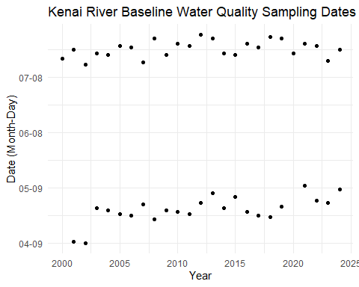

Summary statistics for timing of spring and summer sampling date below.
library(kableExtra)
# Calculate spring and summer average days with tide times
summary_table <- krbwqm_dates %>%
distinct(julian_day, season, year, time_max_tide, time_min_tide) %>%
group_by(season) %>%
summarise(
avg_date = format(
as.Date(round(mean(julian_day)), origin = as.Date("2024-01-01")), "%m-%d"
),
stdev = round(sd(julian_day)),
avg_time_max_tide = format(
as.POSIXct(mean(as.numeric(as.POSIXct(time_max_tide, format = "%H:%M:%S"))), origin = "1970-01-01"),
"%H:%M:%S"
),
avg_time_min_tide = format(
as.POSIXct(mean(as.numeric(as.POSIXct(time_min_tide, format = "%H:%M:%S"))), origin = "1970-01-01"),
"%H:%M:%S"
),
n_years = n(),
min_year = min(year),
max_year = max(year)
)
# Create an attractive table
col_names <- c(
"Season", "Average Date", "+/- Days (StDev)", "Avg Max Tide Time",
"Avg Min Tide Time", "Number of Years", "Earliest Year", "Latest Year"
)
if (knitr::is_html_output()) {
summary_table %>%
kable(
format = "html",
caption = "Spring and Summer Average Dates and Tide Times",
col.names = col_names,
align = c("l", "c", "c", "c", "c", "c", "c", "c")
) %>%
kable_styling(
bootstrap_options = c("striped", "hover", "condensed", "responsive"),
full_width = FALSE,
position = "center"
) %>%
column_spec(2:8, width = "2cm")
} else {
knitr::kable(summary_table,
caption = "Spring and Summer Average Dates and Tide Times",
col.names = col_names)
}
Spring and Summer Average Dates and Tide Times
Season | Average Date | +/- Days (StDev) | Avg Max Tide Time | Avg Min Tide Time | Number of Years | Earliest Year | Latest Year
spring | 04-28 | 7 | 07:25:52 | 20:28:52 | 23 | 2001 | 2024
summer | 07-24 | 4 | 08:05:31 | 19:47:07 | 25 | 2000 | 2024

B.3 Time of Day
# dot plot
krbwqm_dates %>%
ggplot(aes(year,time_max_tide)) +
geom_point() +
facet_grid(.~season) +
ggtitle("Kenai River Baseline Water Quality Sampling Times\nHigh Tides")
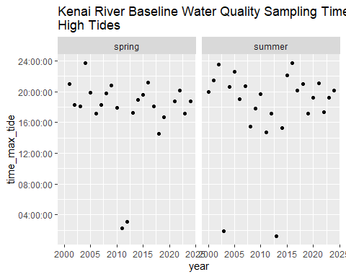
krbwqm_dates %>%
ggplot(aes(year,time_min_tide)) +
geom_point() +
facet_grid(.~season) +
ggtitle("Kenai River Baseline Water Quality Sampling Times\nLow Tides")
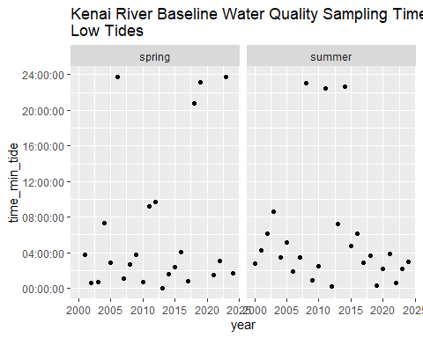

Appendix C — Project Financial History
Updated 2026-03-28, Benjamin Meyer, Kenai Watershed Forum (ben@kenaiwatershed.org)

Appendix C — Summary
- The Kenai River Baseline Water Quality Monitoring project is funded both direct as well as in-kind financial support from project partners.
- Project costs include contractual laboratory expenses, research staff personnel time, equipment, and other smaller expense categories. Partners are invoiced on an annual basis.
- While project support has remained mostly steady, inflation of the U.S. dollar since 2005 (56%) has reduced the purchasing power available to the project since 2005.
- In order to continue Kenai River water quality monitoring efforts, the project must sustain necessary funding levels.
- Download the Project Partner Update Letter Below

C.1 Inflation leads to declining project income
Since the year 2005, inflation of the US dollar has reduced it’s value by 56%. Figure D.1 plots this trend from 2005 - 2023.

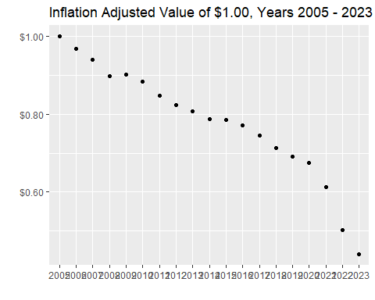
Figure D.1: Inflation Adjusted Value of $1.00, Years 2005 - 2023. Data from https://www.usinflationcalculator.com/.

Adjusted for inflation, project income has seen a steady decline in purchasing power from 2005 - 2022. Figure D.2 displays inflation adjusted project income and expenses history.
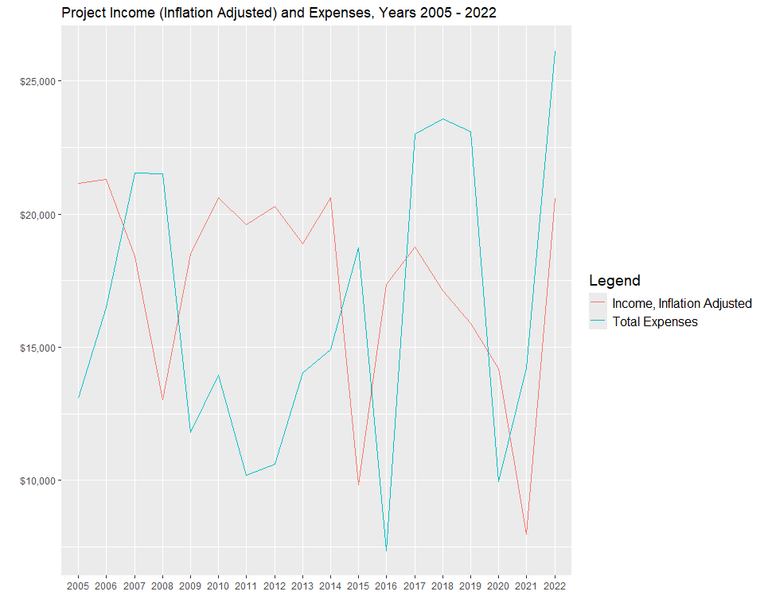
Figure D.2: Project Income (Inflation Adjusted) and Expenses, 2005 - 2022

C.2 Income Detail
Project income history fluctuates annually as partner contributions vary. Figure D.3 below displays annual cash contributions by individual partner organizations. Most partner organizations have continued to contribute a constant annual amount once the original agreement was established.

C.2.1 Notes on income history
In 2022, the project received a lump sum contribution from Kenaitze Indian Tribe that had originally been intended to be dispersed annually over years 2018 - 2022. Similar levels of annual contribution are not anticipated for future years. Additionally, in 2023 the project received a contribution from Salamatof Tribe via it’s IGAP program. As of 2024, the IGAP program is no longer active with Salamatof Tribe, thus further cash contributions are not anticipated.
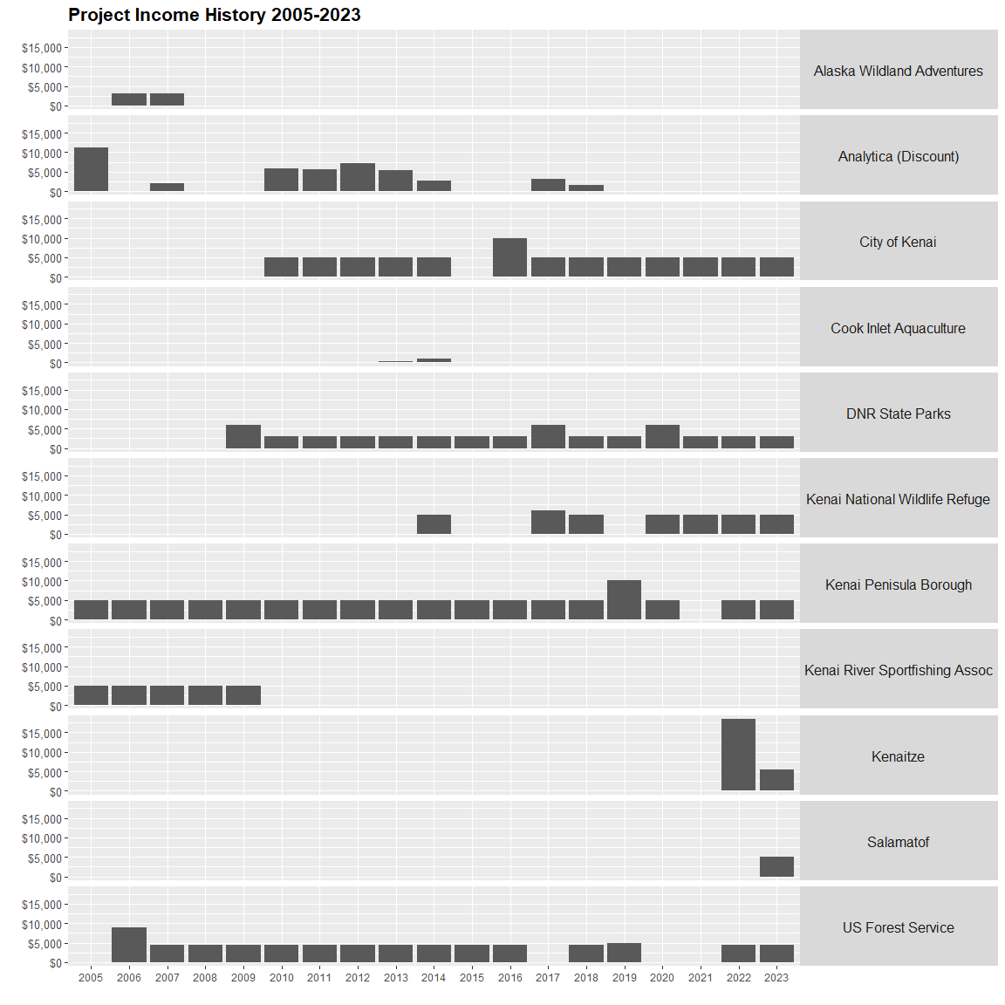
Figure D.3: Income by partner organization
With the atypical timing and receipt of funds from Kenaitze and Salamatof, the project saw increased income in 2022 and 2023; see Figure D.4. However as seen in Figure D.5, when adjusted for inflation, even these two high-income years are lower than typical total annual project income received through year 2014.
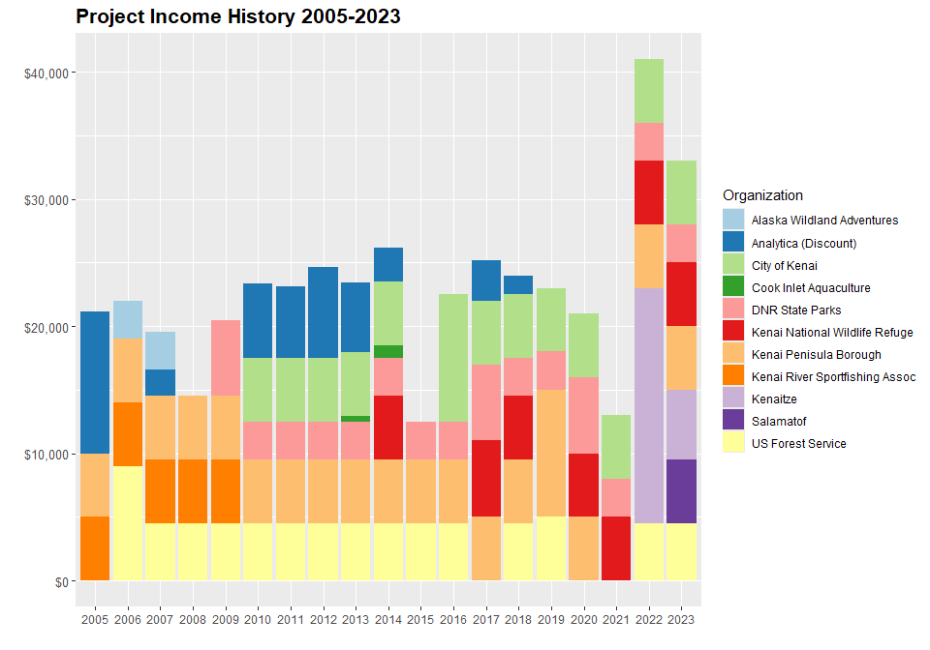
Figure D.4: Project income by partner organization
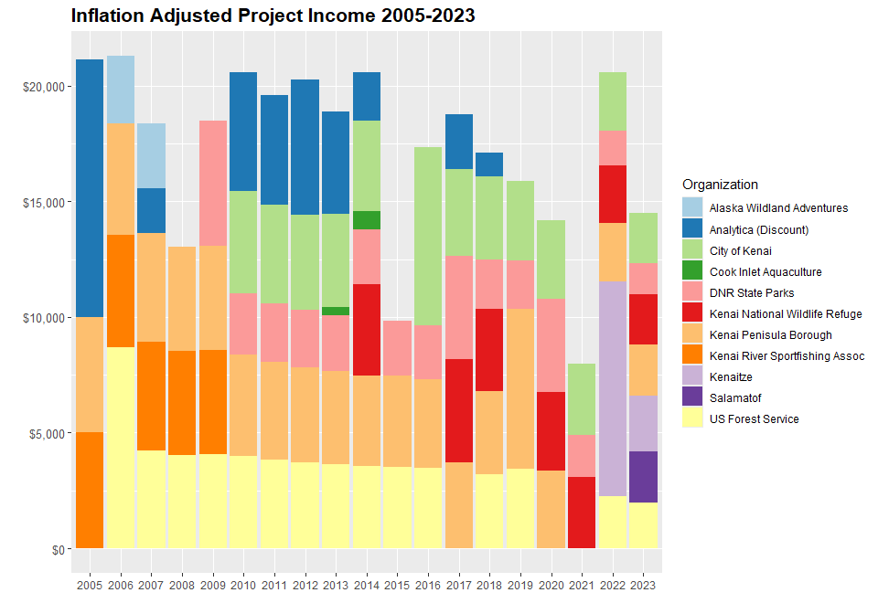
Figure D.5: Project income by partner organization, adjusted for inflation relative from 2005 - 2023
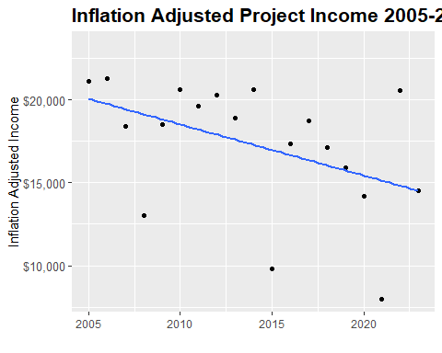
Figure D.6: Total annual project income, adjusted for inflation relative from 2005 - 2023. Accounting for inflation, year 2023 purchasing power is 31% lower (~$6,619 less) than year 2005.

Appendix C — Expenses

C.1 Expenses History
Project expense trends from years 2005 - 2022 are detailed in figure Figure E.1 and source data is available in the link below the figure.
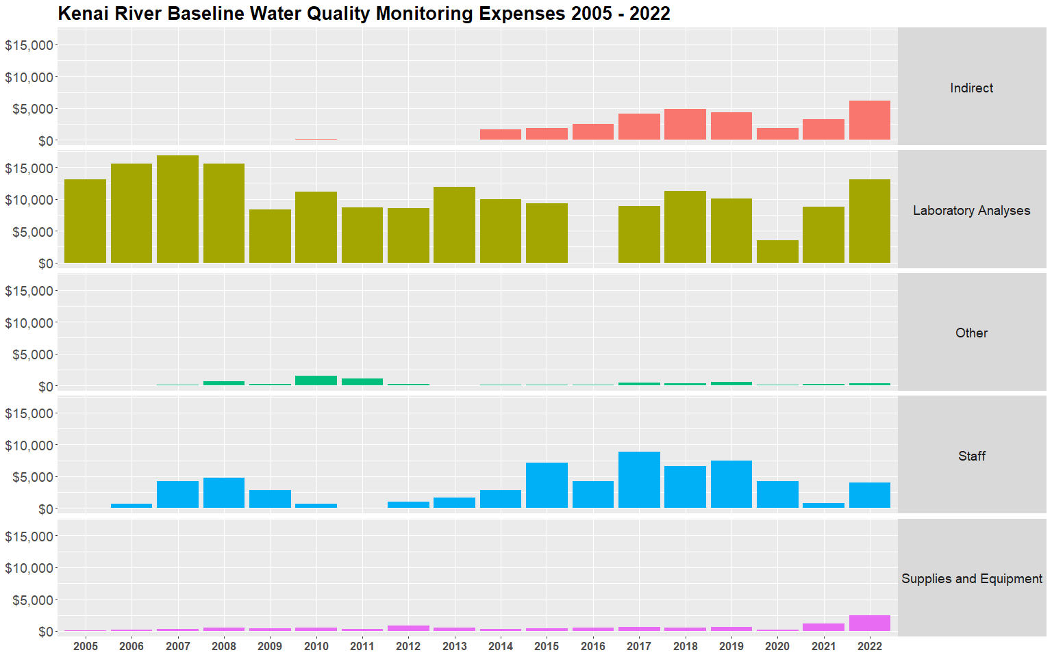
Figure E.1: Kenai River Baseline Water Quality Monitoring Expenses 2005 - 2022

In general, laboratory analysis expenses and staff scientist time are the largest expense categories. In years where little to no staff time was is recorded for the project, staff were funded by similar related projects.

C.2 Projected 2025 Expenses
- Projected 2025 income and expenses are detailed in this Google Sheet: https://docs.google.com/spreadsheets/d/1VbYnY4f8eyhQwbgrpnDrOTIJEsu7pkg_uMbVN5kecKA/edit?gid=1388741346#gid=1388741346
- As of November 2024, a projected income gap of $20,045.84 exists for year 2025.

Appendix C — Recommendations
- Ensure that project income matches project needs
- Project manager will continue to seek new sources of income and efficiency
- Project partners may be asked to annually adjust contributions based on inflation

C.1 Source Data
All source data not linked at this page is available in the project GitHub repository at https://github.com/Kenai-Watershed-Forum/kenai-river-wqx in the following directories:
- other/input/financial
- other/output/financial

https://www.kenaiwatershed.org/science-in-action/research-information/water-quality/
https://dec.alaska.gov/water/water-quality/integrated-report/
https://www.kenaiwatershed.org/kenai-river-baseline-water-quality-monitoring/
https://www.usinflationcalculator.com/
https://www.epa.gov/general-assistance-program-gap

